- Shock advertising is used to gain attention. If an advertisement is controversial, then it gains free publicity through the press and on blogs. Even though this kind of publicity can be negative, it is still publicity nonetheless. Shock advertising leads to brand awareness and an eventual rise in sales. Many companies that use shock advertising do not even show their product. The interest is solely on creating a very memorable impact on their audience. Studies show that shock advertising can be effective for increasing brand awareness and sales.
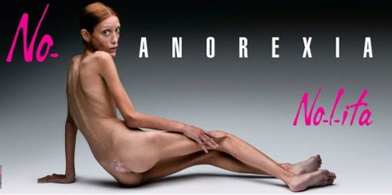

There are many examples of shock advertising from Benetton to Calvin Klein. The image included here is of Isabell Caro who posed for Oliviero Toscani and Nolita Jeans before dying of anorexia. This picture of her emaciated body shocked many viewers and gave Nolita Jeans a lot of publicity.

- Appeal to Fear: In advertisements, speeches or even newspaper articles we see that writers and speakers appeal to their audience's sense of fear. If you can make people scared, then they will believe or buy anything. We see it in advertising, political campaigns and public service announcements. It is an age-old technique used many campaigns from the 'War on Terror' to the 'War on Drugs'.
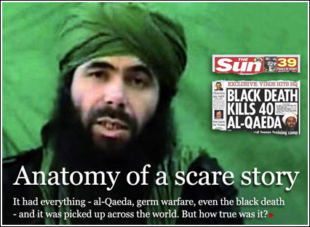

- Conflict: Including a conflict situation in an ad helps sell a product or an idea. This advertising technique relies on the audience's interest in seeing the conflict resolved. If you think about how children are intrigued by fights in the schoolyard, then you understand how conflict in advertising draws our attention to a product. Conflict in advertising can sometimes lead to shock advertising if scandalous or controversial, which goes one step further in creating a media-hype and drawing attention to the product or brand.

An ad as simple as this one for Benetton in the early 1990s includes a conflict that the audience wants to see resolved. We ask questions like: "Why are these men handcuffed together?" "Who has the key?" "Is one a police officer and the other a criminal?" Asking questions like these engages the audience with the image and eventually the product and brand.

- Testimonial: If someone tells you about a personal experience with a product, then you are likely to believe that person. If that 'someone' is a celebrity, you may be even more likely to buy a product that he or she is promoting. This kind of story about a personal experience is known as a 'testimonial'. Testimonials are used in advertising and political campaigns to appeal to the audience's sense of ethos, i.e. that which gives someone credit or a mandate. If a third, independent party has approved of a product or idea through experience, then the speaker's voice is validated. What's more, the audience may be able to identify with person giving the testimonial. This is why the person from the testimonial usually comes from the same demographic group as the target audience.

The 'Got Milk?' campaign is a good example of advertising that relies on testimonials and celebrities. This particular ad featuring Susan Sarandon comments on the importance of milk in providing the nutrients tha families need. She is speaking as both a film star and a mother. Many mothers can understand this importance to provide nutrients for children. Many people simply think: "If Susan Sarandon drinks milk, so should I!"
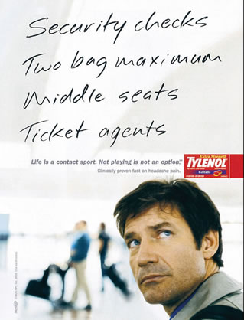
5. Problem/ benefit: If you can convince someone that they have a problem, you can sell them a solution. This is the kind of persuasive technique used by advertisers and politicians, known as the problem / solution technique. If an audience can identify with one characteristic of the problem, then they can be persuaded to believe that they must buy into the solution.

This technique can be found in the Tylenol ad opposite. Many people find air travel a stressful experience. If you can identify with the stress and headache that this passenger is suffering from, you may want to buy Tylenol too.

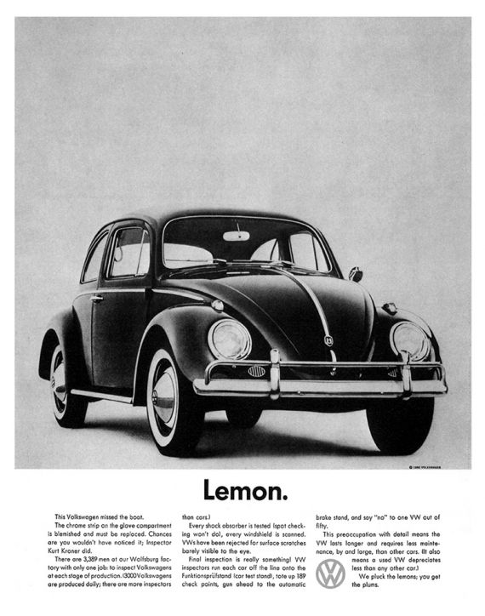
6. An anti-ad draws your attention to and makes you aware of the conventions of advertising. In effect anti-ads seems to tell the audience that they are smart enough to see through the tricks played by advertisers. Not only does an anti-ad break the rules of advertising. It shows you how and why they have done this.

The notion of anti-advertising started in the 1950s with the 'lemon' ad from Volkswagen. 'Lemon', is another world for a bad car. Calling their cars 'lemons' shocks readers into reading the rest of a lengthy infomercial about their strict inspection process at the Volkswagen factory.

7. The bandwagon effect is a propaganda technique that suggests one should do something because everyone else is doing it. It is an argumentation fallacy, because something does not have to be true if everyone is doing it. It comes from the idea of a parade, where happy people go by on bandwagons and people in the crowd have the urge to 'hop on'. The bandwagon effect is an age-old technique used to recruit soldiers for war or sell hamburgers to the masses.

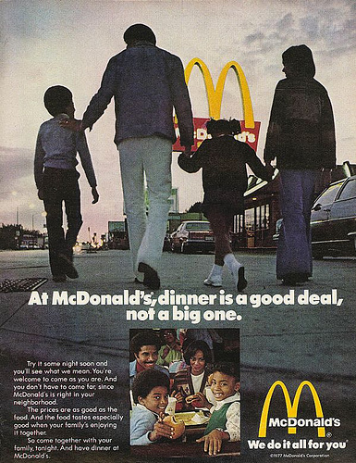

This McDonald's ad is a good example of the bandwagon effect. We see happy people walking by and eating at the restaurant. If we want to be as happy as the people in the ad, then we had better eat at McDonald's.

