Text #1
From 'Cranes'
Jennifer Ackerman
National Geographic 2004
From a blind overlooking the wetlands of central Wisconsin, I can see a long-legged bird in the distance, a stroke of white curled at the top, like a bright question mark against the emerald green grasses. Then up pops another from the screen of reeds. The birds are yearlings, five feet tall, with snow-white plumage and elegant black wing tips that spread like fingers when they fly. They’re quiet now, but from the long trachea coiled in their breastbones may come a wild, singing whoop, harsh and thrilling, that gives their tribe its name.
This would be a primordial scene – big sky, undulations of tall marsh grasses, wild whooping cranes – were it not for a penned area nearby, where several whooper chicks, well camouflaged in tawny feathers, forage in the shallows. In a whisper, crane biologist Richard Urbanek explains that these chicks have been raised in captivity but have never heard a human voice nor seen a human form, except in crane costume. As part of an experimental program to reintroduce a wild migratory population of whooping cranes to the eastern half of North America, these chicks have been fed and tended by crane-costumed people for two months. Now, before they are released to the wild, they are being taught the habits of their ancestors with modern techniques pioneered by Operation Migration, an organization devoted to helping endangered birds learn their traditional migratory routes. Near the pen is a long stretch of open grass, a runway, where the chicks are learning to fly behind an ultralight plane flown by a pilot in crane costume who will guide them from this refuge 1,200 miles south across seven states to wintering grounds in Florida.
Two cohorts have already made such trips – and returned on their own, the first whooping cranes in perhaps more than a century to fly freely over the eastern United States. After three years of ultralight-led migrations, the new eastern migratory population numbers 36 birds, including the yearlings and the chicks. The success of this effort is leading the way for a more ambitious project half a world away in the northern reaches of Russia. In the fall of next year an international migratory route, from Russia to Iran, will restore the birds’ knowledge of the ancient flyway – not with ultralights but with hang gliders that will soar a difficult path extending more than 3,000 miles over four different countries.
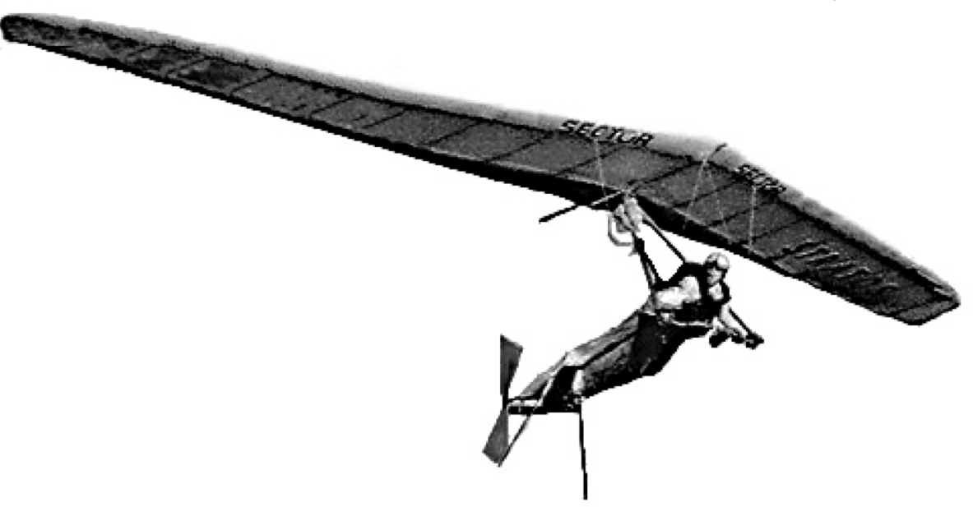Hang glider pilot Angelo d’Arrigo leads a trio of young captive-bred Siberian cranes on a trial flight over the Arctic Circle in Siberia – part of an ambitious effort to teach the endangered birds the migration route of their ancestors from Russia to Iran.
Text #2  'To a Waterfowl'  William Cullen Bryant  1815  Whither, 'midst falling dew,  While glow the heavens with the last steps of day,  Far, through their rosy depths, dost thou pursue  Thy solitary way?  Vainly the fowler's eye  Might mark thy distant flight to do thee wrong,  As, darkly painted on the crimson sky,  Thy figure floats along.  Seek'st thou the plashy brink  Of weedy lake, or marge of river wide,  Or where the rocking billows rise and sink  On the chafed ocean side?  There is a Power whose care  Teaches thy way along that pathless coast,--  The desert and illimitable air,--  Lone wandering, but not lost. | All day thy wings have fann'd  At that far height, the cold thin atmosphere:  Yet stoop not, weary, to the welcome land,  Though the dark night is near.  And soon that toil shall end,  Soon shalt thou find a summer home, and rest,  And scream among thy fellows; reed shall bend  Soon o'er thy sheltered nest.  Thou'rt gone, the abyss of heaven  Hath swallowed up thy form; yet, on my heart  Deeply hath sunk the lesson thou hast given,  And shall not soon depart.  He, who, from zone to zone,  Guides through the boundless sky thy certain flight,  In the long way that I must tread alone,  Will lead my steps aright.
Paper 1 Sample A:

In this comparative commentary, Cranes by Jennifer Ackerman and To a Waterfowl by William Cullen Bryant will be compared and contrasted. Even though one is a scientific, informative article, and the other one is a descriptive poem, they still have a common theme, cranes and their migration.
As mentioned, the theme of both texts is crane migrations. However, the content of the works greatly differs. The article talks about a new crane reserve, where cranes, which are an endangered species, are grown in what looks them like a completely natural environment, but actually, they are still protected by humans, according to the article, in crane costumes. The article says that “these cranes have been raised in captivity, but never heard a human voice nor seen a human form, except in crane costume” (Lines 9,10). The poem is much more personal and talks about a particular
crane’s flight, struggle to escape the hunter and its demise.
As we see, both texts are about cranes, but their audience and purpose is different. To a Waterfowl is a poem and it is meant to express the author’s feelings to the reader through the flight of a crane. The poem is meant for a more mature audience, because it is complex, written in old English, which children can’t easily understand, and has a serious theme. On the other hand, the article doesn’t choose its audience judging by their name and age, it is simply people who are interested in crane migrations, especially in the USA. Its purpose is to inform the reader about the new
crane migration project in central Wisconsin.
Wisconsin is known to be a calm region, and so is the tone of this article. The narration and description are similar to a nature documentary film, we see that in line 7, where the author says “ big sky, undulations of tall marsh grasses, wild whopping cranes”. After the highly descriptive introduction, the narrator goes on to talk about their project. From that point, the article’s scientific mood comes into play. The poem starts off with an easy-going flow, which dramatizes as the hunter appears and gets more and more dramatic until the crane’s death, ultimately leading to a fade-out
effect in the outro.
The stylistic devices in both texts rely heavily on description, especially in the poem, where we see a lot of sensory details, such as weedy lake, rocking billows, crimson sky… This lets us completely imagine the landscape the flight is taking place in. To get the reader more into the poem, the author addresses the reader as he is the crane, like in line 2, where he says “Far, through their rosy depths, dost thou pursue thy solitary way?”. This type of narration gives us the crane’s point of view, but much more importantly, a personal emotional connection with the crane. The stylistic devices in the article are not that broadly used, except for the beginning. This is quite common in scientific articles.
In conclusion, we see how two completely different texts by structure use completely different methods of narration, description, but share a common goal to portray their common theme of crane migrations, be it in a scientific way or an emotional descriptive poem.

Paper 1 Sample B:

People have always been fascinated by birds. Text 1, an article from National Geographic from 2004, and Text 2, a poem by William Cullen Bryant from 1815, show how people and birds learn from each other. While these texts explore experiences that people have with birds, they target different audiences and use different techniques. These differences are largely accounted for by the different contexts in which they were written.
Text 1 is very characteristic of a journalistic article for National Geographic, which targets nature-minded readers. Text 2, on the other hand is characteristic of Romantic poetry from the 19th century, read by literary enthusiasts. We see the journalistic nature of the National Geographic article in its reporting of newsworthy content. There is something extraordinary about people wearing ‘crane costumes’ (line 11) who teach young cranes how to fly and migrate from an ‘ultralight plane’ (line 16). What’s more, the journalist explains that this practice is happening in Siberia as well. Whereas birds learn from people in remarkable ways in Text 1, the poet, William Cullen Bryant learns a life ‘lesson’ (line 26) from one bird in Text 2. Thepoet has written an ode to this waterfowl, who has taught him about the importance of solitude and steadfastness. We know that it is an ode through the use of poetic language, the title ‘To a Waterfowl’, the use of rhyming quatrains and apostrophe, (when a poet asks an object a question). These qualities require readers to hear the spoken word, and therefore the audience is most likely interested in its literary qualities. Both texts are very different in their purpose, as they come from different centuries and target different audiences.
Although the purposes and contexts of these texts are different, they comment on a similar theme: the importance of nature. Text 1 is built on the assumption that nature and the whooping crane must be preserved. Lines 24-27 describe a plan to “restore the birds’ knowledge of the ancient flyway.” The extreme measures that are taken to help these birds migrate, including the costumes, the reserves and the gliders, are never questioned in this article. The message of Text 2 is also built on the premise that nature is important. The poet asks the crane why it pursues its solitary ways (line 4). Eventually he claims that the bird’s purpose is to guide him on his lonely path in life, as stated in the final stanza: “He who, from zone to zone, / Guides through the boundless sky they certain flight, / In the long way that I must tread alone, / Will lead my steps aright.” Its message is very characteristic of Romantic poetry: We can learn how to live through observing nature. As in Text 1, the premise that we must preserve nature and look to it for inspiration is never questioned but affirmed.

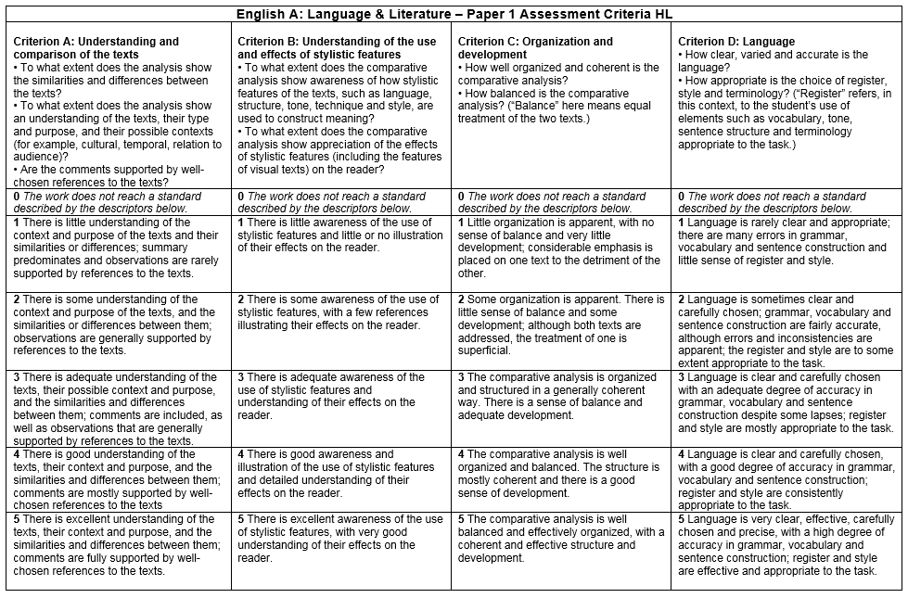

Sample A Level: __________

Sample B Level: __________

Examiner’s Remarks

Sample A: 4-
Sample B: 7+
Criterion A - Understanding and comparison of the texts - 5 marks
The analysis should show and understanding of the similarities and differences between the texts. There needs to be a clear understanding of the target audience, the purpose and the context (where possible) of the text. The comparative analysis must be supported by relevant examples from the texts.
Sample 1.1  1 out of 5 - The student glosses over some of the basic points of these texts. There are many generalizations such as "Wisconsin is a calm region", or "Text 1 is a scientific article." Furthermore the student states that the bird dies in the poem, whereas he simply flies away. While there are few good insights, these are sporadic and simplistic.  Didn’t mention year, or the producers of the text, so audience was not discussed enough.  Did not qualify the audience for either text, shows little understanding of context.  Stated purpose but didn’t not explain it.  References were not explained. | Sample 1.2  5 out of 5 - Although the main idea of the paper is not entirely consistent - at times focusing on nature, then birds and migration - there is a strong sense of understanding of the texts. The student explains how the texts are defined by their form and context. Specificity  Not enough qualification for audience concerning text two.  Purpose was not explained enough
Criterion B - Understanding of the use and effects of stylistic features - 5 marks
The comparative analysis should show an understanding of how various stylistic features, such as tone, style and structure, are used to construct meaning. The analysis should comment on the effects that these features have on their target audience.
Sample 1.1  2 out of 5 - Again the student glosses over many stylistic devices. Especially with regards to Text 2, very few claims about use of language are ever explained or supported with examples. For example the student explains that it is written in old English for a serious audience, without expanding on what is meant by 'old' or 'serious'. In the student's defense, there are references to word choice in Texts 1 and 2 and the effects of these words on their audiences in the second to final paragraph. He could have explained the effects of this language more in depth | Sample 1.2  5 out of 5 - This sample response explains the effects of stylistic devices on their audiences extensively adequately. She states that the choice of vocabulary creates sympathy for nature and the birds. Not only does she identify the structural and stylistic devices of the poem, such as the use of iambs and rhyming schemes, but she explores the effects that these may have on their audience.
Criterion C- Organization and development
The analysis must be well-balanced, meaning that it treats both texts equally. Furthermore, it must be well-structured, coherent and organized.
Sample 1.1  3 out of 5 - While the sample response may lack in substance, it does contain some organization and development. There is a central focus on the importance of migration to both texts. The student uses topic sentences and refers to both texts. Having said this, the student refers much more to Text 1 than Text 2.  Some consistency overall with intro, body and conclusion, but not consistent in analysis of both texts | Sample 1.2  5 out of 5 - This sample response explores both texts equally. What's more, the commentary develops the idea that birds are leaning from people in Text 1 and a person is learning from bird in Text 2. Each paragraph has coherence and references to the texts are well integrated.  Missing a conclusion
Criterion D - Language
The language of the comparative analysis must be clear and accurate. It should be appropriate, meaning it contains formal sentence structure, good choice of words and effective terminology.
Sample 1.1  2 out of 5 – The student's use of register is not always appropriate to the task. Some sentences are rather vague, such as "The stylistic devices in the article are not that broadly used, except in the beginning."  Many general terms, lacking specificity | Sample 1.2  5 out of 5 - This response contains terminology like 'apostrophe' and 'iamb' that show the student's understanding of poetry. The sentence structures are rather sophisticated and the choice of register is highly appropriate to this task.  Specifies conventions and terms based on text type and genre

