SECTION A
Text 1
Kwan
Posted by Liora Ipsum / WWW.BLOGTO.COM
PROFILED ON MARCH 27, 2014 /
REVIEW POLICY
7 Comments
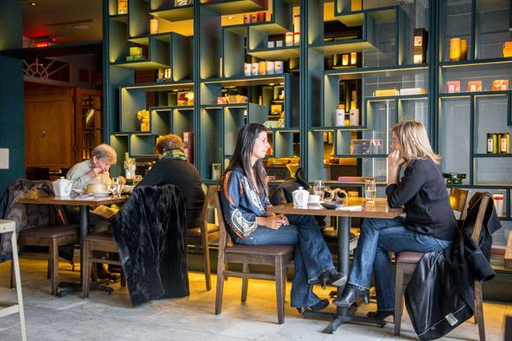
Kwan is a 120-seat dim sum parlour Yonge and St. Clair that takes over the former home of the French restaurant Didier. The space inherits marble floors and wood finishings but melds the existing interior with newly added Asian-influences.
Don't expect rolling cart service, as veteran restaurateur Debbie Lui (formerly of Markham's Royal Tea House) stresses that crafting each dumpling and bun to order yields superior taste and freshness.
The midday menu is vast and varied. Steamed options like shrimp dumplings ($5) are listed alongside fried goodies like taro root balls ($4) and rice flour noodle wraps stuffed with fried tofu with snow pea shoots ($5).
Up next, a deliciously golden fried turnip pancake ($6) specked with salty dried shrimp, preserved pork and fresh chives.
From here on, I start to lose track as a dizzying number of plates makes its way to the table. There's a plate of fried mushrooms and asparagus coated in a peppery seasoned batter, then, puffy BBQ pork-filled buns and bumble bee-shaped almond desserts. Unless otherwise indicated, prices are marked with S, M, L, XL and SP (special) and top out at $8 per order.
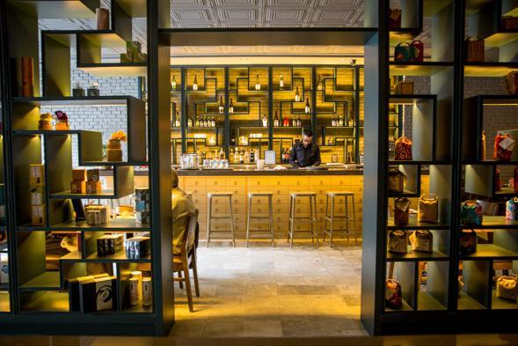
Dim sum service is complete by 4pm at which point the dinner menu comes into effect to offer apps, soups and family-style seafoods, rice dishes and noodles. A five course set menu for $30 includes truffle spring rolls and jumbo chili garlic prawns.
I stick to jasmine tea, though there's also an eclectic wine list ($7.50-$12 by the glass) and selection of beers by the bottle ($5.75-$6.50).
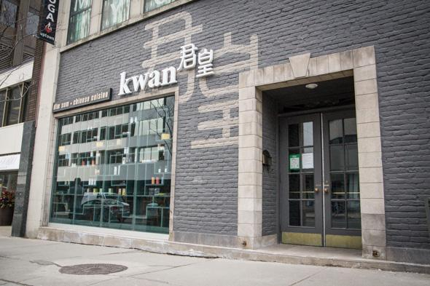
Kwan is open on weekdays from 11:30am to 10pm, and on weekends dim sum starts half an hour earlier. Take-away orders are welcome as are special seafood requests made in advance.
Photos by Jesse Milns

Text 2
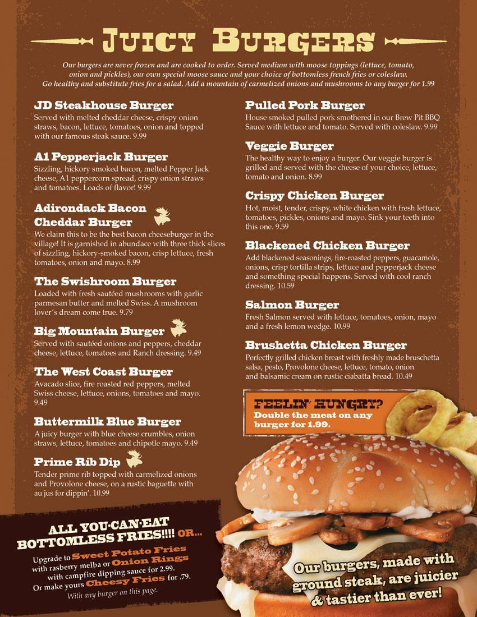

SECTION B
Text 1

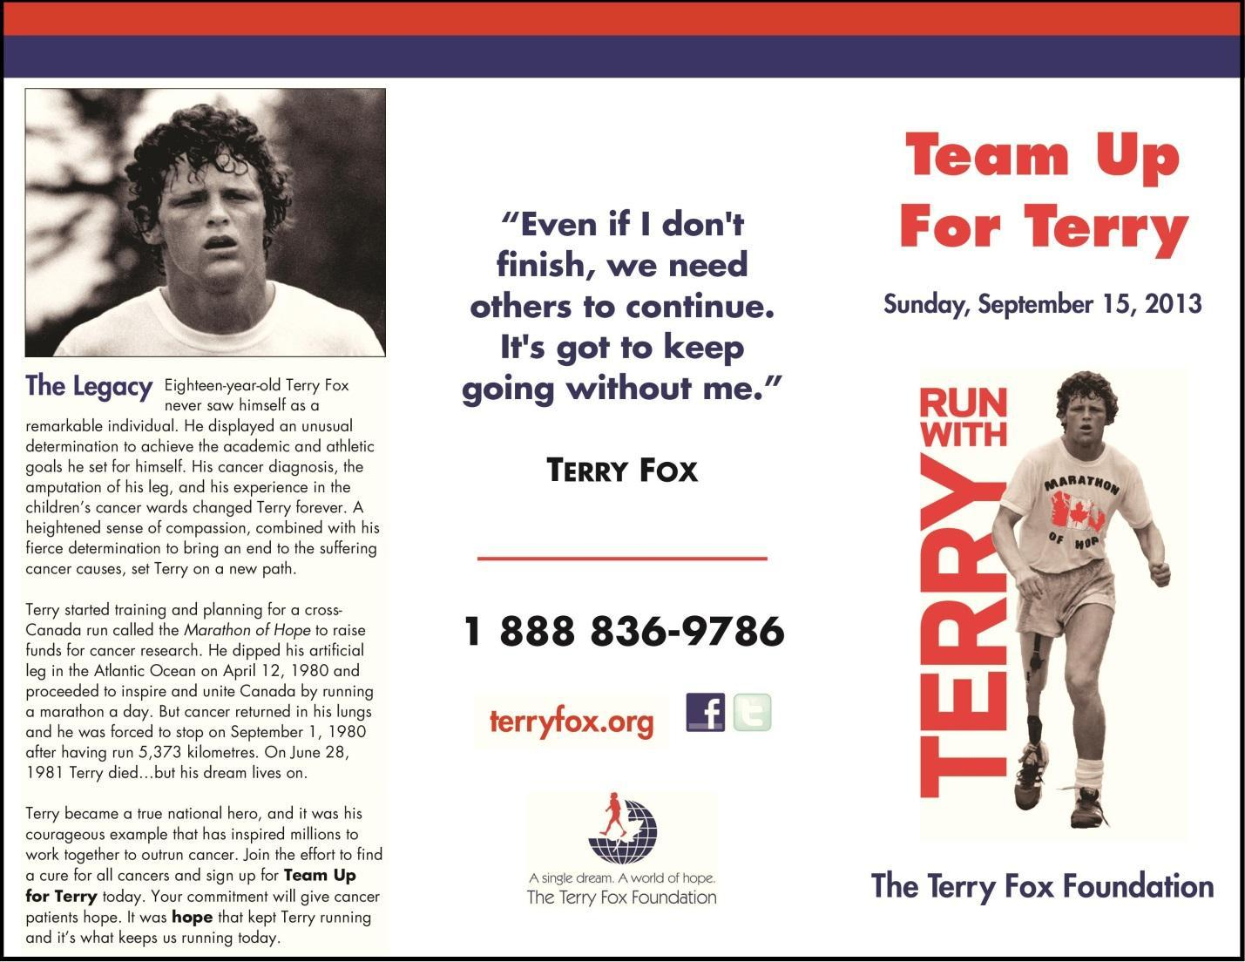

Text 2
06.09.2013in current news
Terry Fox run at York will help raise awareness and funds
The annual Terry Fox Run returns to York University again this September to increase cancer awareness and to keep Terry Fox’s spirit alive.
The run will take place Sunday, Sept. 15, from 9:30am to noon, starting at the Life Sciences Building Courtyard.
The five- kilometre route is still being confirmed. Visit the York Is Uwebsite for updates.
The annual run has become tradition at York and has grown in popularity throughout the year. It is non-competitive and no minimum pledge is required. The goal is to raise money and awareness for cancer research while spreading the story of Terry Fox and his Marathon of Hope.
The run, held at York University since 1992, is open to the public, all the York students and staff, community groups, as well as neighboring residences, allowing all participants to explore the campus and beyond.
During the run, York Is U volunteers and coordinators will assist and motivate runners, as well as to provide water and food to keep runners energized throughout the day. Following completion of the run, participants will receive the Terry Fox Certificate to show off their accomplishment.
Last year’s outcome for the run was tremendous, this year the hope is to increase both the number of participants and the amount of money raised. On top of that, the goal is to provide York students the opportunity to engage within the vibrant community at York, build a sense of belonging on campus and help students earn Torch Points for their colleges.
For more information, contact York Is U ambassador Ariel Phan at yueventa@yorku.ca.
For more University news, photos and videos, visit the YFile homepage.
SECTION C
Text 1

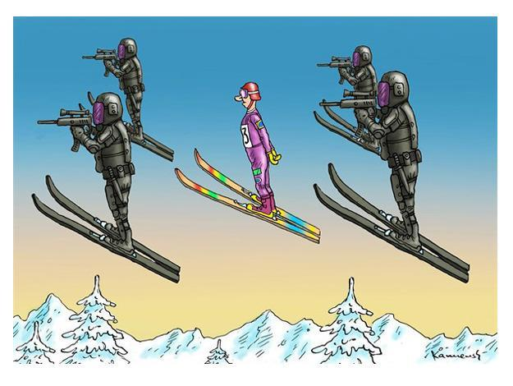

Text 2
www.sanfransisco.cbslocal.com
Google Goes Rainbow For 2014 Winter Olympics In Homophobic Sochi
by Brandon Mercer
February 6, 2014 8:10 PM
Share on email19
View Comments
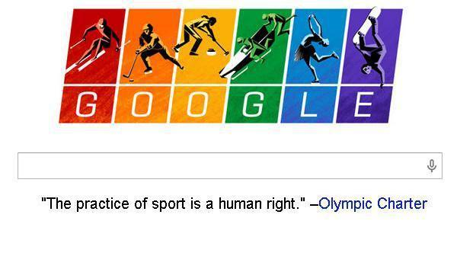
(Credit: Google Logo)
Related Tags:
2014 Winter Olympics, Anti-Gay, Dennis Hwang, Doodle, Google, Homophobic, Human Rights,Logo, Olympic Charter, Olympics, Sochi, Winter
GET BREAKING NEWS FIRST
Receive News, Politics, and Entertainment Headlines Each Morning.
Sign Up
MOUNTAIN VIEW (CBS SF) — No stranger to using its corporate muscle to make political statements, on the eve of the 2014 Sochi Winter Olympics, Google changed its ubiquitous search engine logo to rainbow colors and included a quote from the Olympic Charter at the bottom.
Google writes below the search box, “The practice ofsport is a human right.”
A click on the multi-hued logo takes you to a search for “Olympic Charter.”
RELATED: Entire Olympic Charter Document
Host nation Russia recently passed a law banning “gay propaganda,” fueling a firestorm of controversy ahead of the games, and prompting several prominent gayathletes including Bay Area native Brian Boitano, to head to the games as part of the United States delegation.
“First and foremost I am an American athlete and I am proud to live in a country that encourages diversity, openness and tolerance,” said the 1988 figure skating gold medalist to the Associated Press. “As an athlete, I hope we can remain focused on the Olympic spirit which celebrates achievement in sport by peoples of all nations.”
Sochi’s mayor Anatoly Pakhomov added to the heated atmosphere last week, saying, ““It’s not accepted here in the Caucasus where we live. We do not have them [gays] in our city.”
Reporters were quick to point out a number of gay bars in the city, suggesting the mayor may be out of touch with the club scene in the resort town.
RELATED: Sochi Mayor Says No Gays In City.
The Olympic Charter, highlighted in the doodle, could one day include a mention of sexual orientation. In a recent news conference, International Olympic Committee president Thomas Bach said, ”We stand against any kind of discrimination for whatever reason,” and he indicated he was receptive to the idea.
The logos or doodles, drawn up for years by Dennis Hwang and his team at Google’s campus have paid homage to holidays, international events, and occasionally, political issues, especially human rights.
Google employees take into account search engine user input, and staffer ideas, but the selection of a doodle is meant to reflect, “Google’s personality and love for innovation.”
The first doodle came from Google’s founders, who did an homage to Burning Man in 1998, just in case the site crashed, and they were too far into the Nevada desert to do anything about it.
Recent doodles have celebrated less political topics including Ukraine, Harriet Tubman, and Lunar New Year.

SECTION D
Text 1
An excerpt from
Wolfgang Amadeus Mozart
A Biography
Piero Melograni
Prologue • June 1765 In a London Tavern
In July 1765, in a London tavern with the inviting name the Swan and Harp, in Cornhill, a district not far from St. Paul’s Cathedral, Leopold Mozart presented his two children, Maria Anna, called Marianne or Nannerl (who was fourteen) and Wolfgang (who was nine) to the public. In a flier written by their father the two children were presented as “Prodigies of Nature.” Both children played the harpsichord well, but little Wolfgang was astonishing. He could read any piece of music at sight, improvise on a theme suggested to him, and name any note produced by any instrument or even a bell, a drinking glass, or a mechanical clock. What is more, he was an elegant child, self-assured and charming. The father glowed with legitimate pride at the prowess of his son. Leopold had not only fathered the child, but had provided him with his musical training and taught him to read, write, and figure sums. In short, Wolfgang Amadé Mozart was his father Leopold’s biological and pedagogical masterpiece.
London was one halt in a trip throughout Europe that Nannerl, Wolfgang, and their parents had begun two years earlier. They had already played before bankers, dukes, princes, and sovereigns, among them Maria Theresa of Austria and Louis XV, the king of France. They had been in London for over a year and had been received at Buckingham Palace by King George III and his consort, Queen Charlotte Sophia. They had been received with honor in many aristocratic houses in London and had already given a concert with a paid admission set at half a guinea (10s. 6d.) in the Great Room of Spring Garden, near St. James Park.
Before the two siblings left England (never to return), however, they gave a concert in the Cornhill tavern for the bargain price of 2s. 6d., as stated in the announcement written by Leopold and published in the Public Advertiser of 8 July 1765. Wishing to earn money, Leopold Mozart had decided to turn to the middle class of shopkeepers, professional people, and craftsmen, declaring that the two child prodigies would play for several days from noon to three in the afternoon in that smoky London tavern. The announcement invited anyone who wanted to hear and admire them to hurry, and in fact by the end of July the entire Mozart family would leave England to return to the continent.
Text 2
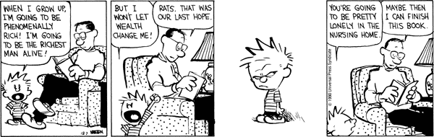

SECTION E
Text 1
British Government’s Protect and Survive Pamphlet
1980

Read this booklet with care
Your life and the lives of your family may depend upon it

Do as it advises
Keep it safely at hand

1 Challenge to survival
Everything within a certain distance of a nuclear explosion will be totally destroyed. Even people living outside this
area will be in danger from -

HEAT AND BLAST
FALL-OUT

Heat and Blast
The heat and blast are so severe that they can kill, and destroy buildings, for up to five miles from the explosion.
Beyond that, there can be severe damage.

Fall-out

Fall-out is dust that is sucked up from the ground by the explosion. It can be deadly dangerous. It rises high in the air and can be carried by the winds for hundreds of miles before falling to the ground. The radiation from this dust is dangerous. It cannot be seen or felt. It has no smell, and it can be detected only by special instruments. Exposure to it can cause sickness and death. If the dust fell on or around your home, the radiation from it would be a danger to you and your family for many days after an explosion. Radiation can penetrate any material, but its intensity is reduced as it passes through - so the thicker and denser the material is, the better.
2 Planning for survival
Stay at Home
Your own local authority will best be able to help you in war. If you move away - unless you have a place of your own to go to or intend to live with relatives - the authority in your new area will not help you with accommodation or food or other essentials. If you leave, your local authority may need to take your empty house for others to use. So stay at home.

Plan a Fall-out Room and Inner Refuge
The first priority is to provide shelter within your home against radioactive fall-out. Your best protection is to make a fall-out room and build an inner refuge within it.

PLAN YOUR SURVIVAL KIT
Five essentials for survival in your Fall-out Room

1 Drinking Water
You will need enough for the family for fourteen days. Each person should drink two pints a day - so for this you will need three and a half gallons each. You should try to stock twice as much water as you are likely to need for drinking, so that you will have enough for washing. You are unlikely to be able to use the mains water supply after an attack - so provide your drinking water beforehand by filling bottles for use in the fall-out room. Store extra water in the bath, in basins and in other containers.
Seal or cover all you can. Anything that has fall-out dust on it will be contaminated and dangerous to drink or to eat. You cannot remove radiation from water by boiling it.

2 Food
Stock enough food for fourteen days.
Choose foods which can be eaten cold, which keep fresh, and which are tinned or well wrapped. Keep your stocks in a closed cabinet or cupboard.
Provide variety. Stock sugar, jams or other sweet foods, cereals, biscuits, meats, vegetables, fruit and fruit juices. Children will need tinned or powdered milk, and babies their normal food as far as is possible. Eat perishable items first. Use your supplies sparingly.
3 Portable Radio and Spare Batteries
Your radio will be your only link with the outside world. So take a spare one with you if you can. Keep any aerial pushed in. You will need to listen for instructions about what to do after the attack and while you remain in your fall-out room.

Text 2
An excerpt from The Road
Cormac McCarthy
2007

They crossed the river by an old concrete bridge and a few miles on they came upon a roadside gas station. They stood in the road and studied it. I think we should check it out, the man said. Take a look. The weeds they forded fell to dust about them. They crossed the broken asphalt apron and found the tank for the pumps. The cap was gone and the man dropped to his elbows to smell the pipe but the odor of gas was only a rumor, faint and stale. He stood and looked over the building. The pumps standing with their hoses oddly still in place. The windows intact. The door to the service bay was open and he went in. A standing metal toolbox against one wall. He went through the drawers but there was nothing there that he could use. Good half-inch drive sockets. A ratchet. He stood looking around the garage. A metal barrel full of trash. He went into the office. Dust and ash everywhere. The boy stood in the door. A metal desk, a
cashregister. Some old automotive manuals, swollen and sodden. The linoleum was stained and curling from the leaking roof. He crossed to the desk and stood there. Then he picked up the phone and dialed the number of his father's house in that long ago. The boy watched him. What are you doing?

A quarter mile down the road he stopped and looked back. We're not thinking, he said. Wehave to go back. He pushed the cart off the road and tilted it over where it could not be seen and they left their packs and went back to the station. In the service bay he dragged out the steel trashdrum and tipped it over and pawed out all the quart plastic oilbottles. Then they sat in the floor decanting them of their dregs one by one, leaving the bottles to stand upside down draining into a pan until at the end they had almost a half quart of motor oil. He screwed down the plastic cap and wiped the bottle off with a rag and hefted it in his hand. Oil for their little slutlamp to light the long gray dusks, the long gray dawns. You can read me a story, the boy said. Cant you, Papa? Yes, he said. I can.

On the far side of the river valley the road passed through a stark black burn. Charred and limbless trunks of trees stretching away on every side. Ash moving over the road and the sagging hands of blind wire strung from the blackened lightpoles whining thinly in the
wind. A burned house in a clearing and beyond that a reach of meadowlands stark and gray and a raw red mudbank where a roadworks lay abandoned. Farther along were billboards advertising motels. Everything as it once had been save faded and weathered. At the top of
the hill they stood in the cold and the wind, getting their breath. He looked at the boy. I'm all right, the boy said. The man put his hand on his shoulder and nodded toward the open country below them. He got the binoculars out of the cart and stood in the road and glassed the plain down there where the shape of a city stood in the grayness like a charcoal drawing sketched across the waste. Nothing to see. No smoke. Can I see? the boy said. Yes. Of course you can. The boy leaned on the cart and adjusted the wheel. What do you see? the man said. Nothing. He lowered the glasses. It's raining. Yes, the man said. I know.
SECTION F
Text 1
Advertisement for Craft Master paint by number kit circa 1950s
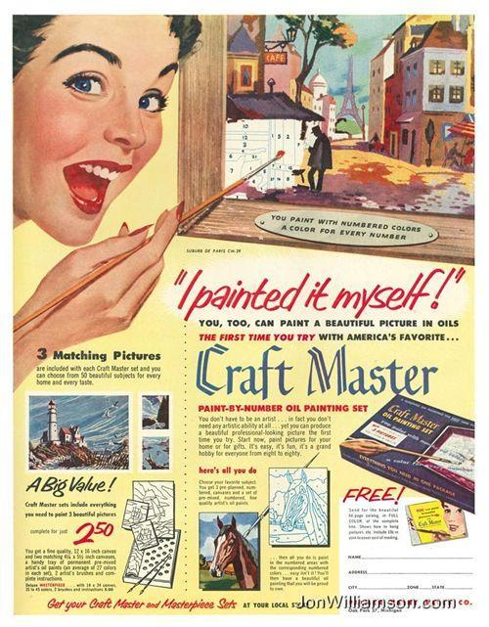

Text 2
so you want to be a writer?
by Charles Bukowski
(2003)

if it doesn't come bursting out of you
in spite of everything,
don't do it.
unless it comes unasked out of your
heart and your mind and your mouth
and your gut,
don't do it.
if you have to sit for hours
staring at your computer screen
or hunched over your
typewriter
searching for words,
don't do it.
if you're doing it for money or
fame,
don't do it.
if you're doing it because you want
women in your bed,
don't do it.
if you have to sit there and
rewrite it again and again,
don't do it.
if it's hard work just thinking about doing it,
don't do it.
if you're trying to write like somebody
else,
forget about it.

if you have to wait for it to roar out of
you,
then wait patiently.
if it never does roar out of you,
do something else.

if you first have to read it to your wife
or your girlfriend or your boyfriend
or your parents or to anybody at all,
you're not ready.

don't be like so many writers,
don't be like so many thousands of
people who call themselves writers,
don't be dull and boring and
pretentious, don't be consumed with self-
love.
the libraries of the world have
yawned themselves to
sleep
over your kind.
don't add to that.
don't do it.
unless it comes out of
your soul like a rocket,
unless being still would
drive you to madness or
suicide or murder,
don't do it.
unless the sun inside you is
burning your gut,
don't do it.

when it is truly time,
and if you have been chosen,
it will do it by
itself and it will keep on doing it
until you die or it dies in you.

there is no other way.

and there never was

SECTION G
Text 1

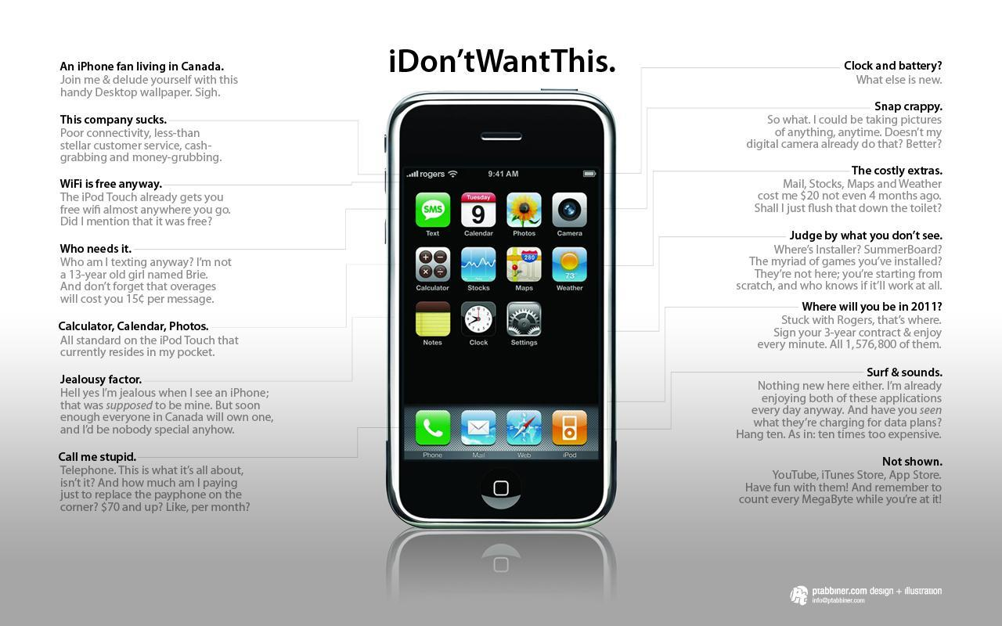

Text 2
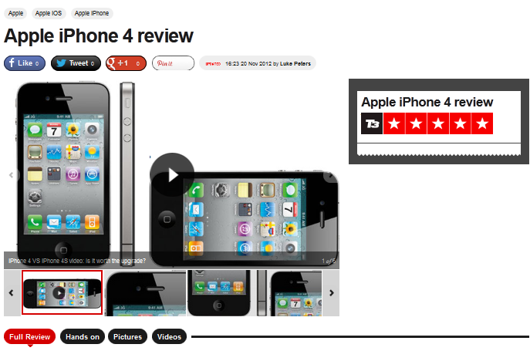
The Apple iPhone 4 builds on the success of the iPhone 3GS, but now it has a successor of its own - the Apple iPhone 4S
Apple iPhone 4 review
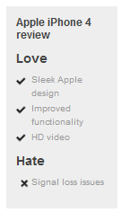
Following all the hype and hysteria we have come to expect with the launch of Apple products, the Apple iPhone 4S is finally about to land, leaving a trail of smartphones in its wake. However, don't go writing off its predecessor, the iPhone 4, just yet.
Despite being one of the most remarkable phones of the past five years, the Apple iPhone 4 landed with a troubling signal loss issue for anyone holding the iPhone 4 “incorrectly” – who knew prior to June 24 2010 that there was a “correct” way to hold mobiles?
Our findings so far are that when you hold the iPhone 4 with your hand covering the bottom left corner, there is a loss of signal. However, we have not found that this has caused us to drop calls or lose data connections when out and about actually using the handset.
Whether this is because we’re subconsciously moving our hands to avoid the issue developing is hard to say. That aside, there is no denying that the Apple iPhone 4 is a stunning piece of tech.
iPhone 4: Size and build
The handset is 24 per cent slimmer than the 3GS at just 9.3mm thick, beautifully compact and elegantly designed with a stainless steel band separating the handset’s scratch-resistant glass covered front and back.
It’s this steel band, which is also the aerial, which seems to be causing the problems. Presumably it’s something to do with contact between the metal band and human skin causing conductivity issues as putting a casing on the iPhone seems to alleviate the problem. Bizarre reception flaws aside, the iPhone 4 is a great showcase for Apple’s technological and design prowess. The combination of the new Apple iOS 4 operating system and a noticeably faster processor than the iPhone 3GS make using it a very smooth and enjoyable experience.
iPhone 4: Screen
The new 3.5-inch Retina Display is another big improvement over the 3GS – and all other mobile devices for that matter. With an 800:1 contrast ratio and 960x640p resolution – according to Apple, that’s more than the human eye can process at that size of screen – the Retina Display sets a new benchmark for mobile screens.
The Retina Display is a joy to use indoors and at most outdoor light levels, although it becomes reflective and difficult to admire when in direct, bright sunlight.
Although adding a gratifying pop to images and videos, older applications and their icons can also appear dated and grainy on the new high-res screen – app developers will have to improve their wares for the iPhone 4. They’ll also have to adapt their apps to allow them to be part of the newly added multi-tasking in iOS 4.
iPhone 4: Performance
Bringing the iPhone 4 to life is the same sprightly Apple A4 processor found in the iPad. You’d think that packing this hefty workhorse under the bonnet would drain the battery, but the new iPhone’s battery life is not noticeably diminished from the 3GS, and Apple claims it actually lasts longer.
As noted, iOS 4 brings multitasking to the new Apple handset. This feature is reliant on the compatibility of apps, but this should cease to be an issue pretty sharpish: iPhone purchasers are not likely to look kindly on app developers who don’t update to support multitasking.
iOS 4 is no one trick pony. The ability to create folders for your apps is another very welcome addition, as is the option to set homescreen images, scrapping the any-colour-as-long-as-it’s-black background of previous models.
iBooks makes the jump from Apple iPad 2 to iPhone with the arrival of iOS 4 and thanks to the iPhone 4’s Retina Display offers up text of impeccable clarity. Crystal-clear fonts similarly enhance web browsing, email and all other text-based functionality. The addition of iBooks will no doubt be a further cause to the iPhone’s success with the commuter market
iPhone 4: Camera
Following repeated cries from consumers, the iPhone 4 now offers flash. No, not the Adobe version for viewing web video – that’s just not gonna happen, so get used to it – but a scorchingly bright LED flash to accompany the improved camera.
Stills are not suddenly of compact camera quality, but they are undeniably better, and bigger at five megapixels. Video is much improved, with 720p HD video offering pristine and sharp detail on the Retina Display.
However, some detail seems to be lost when compressing for direct uploading to YouTube. In-camera editing is also straightforward, and you can add the iMovie app (£2.99) if you want more sophisticated editing of your clips. In addition to the main, rear camera there’s a second, front-facing one. This offers decent picture quality, but it’s there for more than just vanity’s sake. Apple, you see, is attempting to transform video calling from its current status as the forgotten starlet of the tech world into a must-have feature.
To this end, it’s included the Skype-style Face Time app. Given that this works only over Wi-Fi and only between one iPhone 4 and another, we can’t see it reviving video calling’s fortunes, somehow, but it does work nicely enough, with much better video quality than on earlier mobile systems
iPhone 4: Verdict
The Apple iPhone 4 is another classic slice of Apple. In just 12 months Steve Jobs and his band have again redefined mobile handsets.
From the simply beautiful Retina Display to the addition of HD video, and from the idiot-proof UI to the attempted reinvention of video calling, the Apple iPhone 4 is a majestic piece of kit that will no doubt steal hearts. As long as that signal-loss issue doesn’t prove to be a killer, anyway…
Apple iPhone 4 release date: Available now
Apple iPhone 4 price: From £319

SECTION H
Text 1
Apparel industry outsourcing costs garment workers' lives in Bangladesh
Scott Nova, guardian.co.uk, Thursday 13 December 2012 18.30 GMT
Until western consumers make safety standards an issue for the big clothing brands, factory fires will continue to take lives
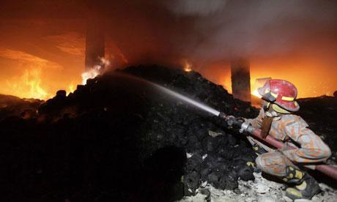
A firefighter tries to control a fire at a garment factory in Savar on the outskirts of Dhaka Photograph: Andrew Biraj/Reuters
The fire that killed 112 workers in a factory producing for Walmart, Sears, Disney and other apparel corporations was the deadliest in the history of Bangladesh, but it was one in a long series of such fires and it will not be the last. The economic logic of the apparel industry, driven by the insatiable hunger of western apparel companies for cheap clothes, guarantees that many more workers will die.
In the last two years, fires in Bangladesh and Pakistan have taken the lives of nearly 500 apparel workers, at plants producing for Gap, H&M, JC Penney, Target, Abercrombie & Fitch, the German retailer KiK and many others.
These deaths are preventable. In the wake of the infamous Triangle Shirtwaist fire, which killed 146 workers in Manhattan in 1911, a labor reform movement transformed the sweatshop-dominated US apparel industry into one defined by safe workplaces, middle-class wages and strong unions. The industry has known for more than 100 years how to operate an apparel factory safely, yet today these lessons are routinely ignored.
The key to understanding why apparel workers' lives are treated so cavalierly today is to ask why corporations are flocking to countries like Bangladesh in the first place. Bangladesh is now the world's second-largest apparel producer. It did not attain that status by achieving high levels of productivity, or a strong transportation infrastructure; it got there by being the rock-bottom cheapest place to make clothing.
This derives from three factors: the industry's lowest wages (a minimum apparel wage of 18 cents an hour), ruthless suppression of unions, and a breathtaking disregard for worker safety. The industry in Bangladesh has been handsomely rewarded for its costcutting achievements, with an ever-rising flood of business from western brands, moderated only by the global recession. And local factory owners understand that if they do not continue to offer the lowest possible prices, those brands will be quick to leave.
Leading apparel companies have accomplished a form of time travel: they have recreated 1911 working conditions in 2012. Unconstrained by regulation, apparel producers in 1911 New York did not waste money on niceties like workplace safety. Neither do their counterparts today in South Asia. By outsourcing their production, US corporations have escaped the regulatory strictures won by unions and labor rights advocates after the Triangle fire and have turned back the clock on a century of workplace reform.
As news emerged of the horror at the Tazreen Fashions factory in Bangladesh, the brands and retailers producing at the facility predictably sought to distance themselves. Unable to deny their relationship to the factory – because of photographs taken by courageous local activists that proved their garments were found inside the building – Walmart and Sears resorted to the claim that their clothes were being made there without their knowledge. They put the blame on local contractors who purportedly subcontracted their orders to Tazreen against the companies' wishes.
Walmart, a company whose foundational corporate principle is cost reduction through micromanagement of the supply chain, was reduced to asserting that it has so little control of its supply chain that it doesn't know which factories in Bangladesh are making its clothes. The brands and retailers also insisted that the unsafe conditions that killed the workers at Tazreen Fashion existed despite their ostensibly robust efforts to ensure safe and responsible labor practices by their suppliers. Walmart touts its "work across the apparel industry to improve fire safety education and training in Bangladesh."
Indeed, virtually every major apparel company claims to be policing its suppliers' labor practices through aggressive inspections. Yet every one of the factories where fires killed workers in Bangladesh and Pakistan in the last two years had been subject to numerous such inspections. The factory where 289 workers were killed in Pakistan this September had received, just weeks before the fire, a clean bill of health under an inspection system called SA-8000. A plant in Bangladesh that burned in 2010 had been inspected by Gap and other customers, but those companies failed to correct the safety hazards that eventually killed 29 workers. The Tazreen factory was an obvious fire trap, yet none of the audits conducted by Walmart (pdf) and other buyers brought about any apparent change.
All the companies concerned publish official policy statements on these issues – Walmart, Gap, Sears, Disney, Target, Abercrombie & Fitch, H&M, JC Penney, and KiK (pdf) – but the problem is straightforward: it costs more to produce under good working conditions than bad

Text 2:

Max Hochfield

Job: Operator
8th floor
Interview: January 20, 1957
I came to this country in December, 1910. My father thought that being an operator was the best trade in the world, and he insisted that my sister take me up to the Triangle Waist Co. But she wanted me to learn plumbing, or to become an electrician – a man’s work.
After working about two or three weeks with her, I became quite skillful.
It happened that, at that time, my sister met a young man, and they were engaged to be married.
At that time we made an engagement party for my sister on Sunday night. It lasted until about twelve o’clock in the morning. Naturally we couldn’t go to work the next day. And when we didn’t come to work the next day our machines were given to somebody else. When we came to work on Tuesday we were sent to the 9th floor to work.
Maybe if my sister wasn’t engaged, she would be alive today.
At that time most of the people in the shop were foreigners.
As I recall, the fire started on the 8th floor just about quitting time. I never waited for the elevator because the elevators were too crowded and most of the time they got stuck.
My sister knew that her boy friend was waiting for her downstairs, so she went into the dressing room.
I suppose I went over to the elevator. I heard some noise, so I thought to myself “I guess the elevator is out of order again,” I walked down the stairs from the 9th to the 8th floor, I saw the entire 8th floor aflame. Nobody there. When I looked toward the windows I saw people coming down the fire escape, I stopped and looked, I was confused, I couldn’t understand. This was the first time I had ever seen a fire.
I wanted to go back and get my sister, but as I turned back there was a fireman. He grabbed me by the shoulder. He says “What are you doing here?” I said “I want to go back. My sister’s up there, I have to save my sister!” He says “You had better go down if you want to stay alive.”
I went down to the 7th floor. I still wanted to go back, but I couldn’t any more because the flames were all over in the hallway, I stayed for awhile as the girls came down the hallway. I thought maybe one of them would be my sister.
The fireman ordered me down, and when I came out on the street I saw people jumping from the windows.
My sister was burned to death. She was so badly burned we couldn’t identify her, but her boy friend did identify her. My sister’s name was Esther Hochfield. She was about 20 years old at the time. I worked at the Triangle only three months, but she had worked there about three years. She was one of the strikers at Triangle in 1909.
We hardly ever saw the main boss, Blanc. They had a lot of foreladies.
I don’t know how the fire started on the 8th floor, but I can tell you that if the door on the 9th floor had been opened I think most of the people would have been saved. There were two exits, but they kept the door locked because every night, when we went home, each girl had to open her pocketbook showing the man that she didn’t steal any lace or trimmings. There were very few men on the 9th floor, and perhaps if there had been more they would have tried to smash the door with a machine.
Nobody warned them.
The floors were wooden floors and, in places, were soaked with oil. The work baskets were wicker baskets. At each machine, and in each basket, there were the parts of from four to five dozen blouses.
We went to look for my sister the next day. We looked for her for a whole week.
Nobody ever questioned me about the fire. No one was interested.
After the fire I was afraid to work for awhile. Even today – when I go to a theatre, or movie, or any crowded place – I want to make sure the place is fireproof.
I joined Local 25 in that same year – 1911. The firm planted spies at the meetings we held after the fire. These people were also working people, and I understand they got good pay. Then, at the trial, these people said we were coached what to say at the trial.
I was called as a witness, but all I was asked was my name and how long was I in this country. I was ready to tell them the whole story. I asked for an interpreter, but I was told that I was doing all right. They cut the questioning short, of course, because they knew that I had lost my sister and they didn’t want to ask me any questions.
Let me tell you a secret. As far as pay was concerned, it was better there than in other shops.
I wanted to take revenge on the firm. I thought of an idea. I didn’t have any money. I thought, where can I get money to buy a gun. And I thought to myself, I’ll go up to Local 25 – I think, at that time, Baroff was manager – and I had expected that someone there with some authority would give me money. And I am going to buy a gun, and I am going to shoot these guys.
Then we had to collect a week’s wages. It was announced in the papers that they opened up a new factory in the same neighborhood. We were supposed to get the wages. So I figured it out that I would go to collect the week’s wages I was sure the bosses would be there, and I was right. They were there – and the little manager too,
I met one of the clerks from the union, I saw there was nobody around. I confided to him the secret I was carrying in my heart. I can’t let it go by. Now is an opportunity for me to get revenge on them. If I can only get a-hold on a gun. He listened to me, and he said: “Look, don’t do it. You’re a young fellow. I know you lost your sister. Take my advice. Don’t do it. It wouldn’t do you any good. It wouldn’t do us any good. Forget it!”
Still in all, if I had any other source of getting money and knew where to buy a gun, perhaps I would have gone through with my plans.
I saw the floorlady of the 9th floor stand in the window waving her pay envelope. But she didn’t have the courage to jump.
-- From “Remembering the 1911 New York Triangle Factory Fire,” http://www.ilr.cornell.edu

SECTION I
Text 1
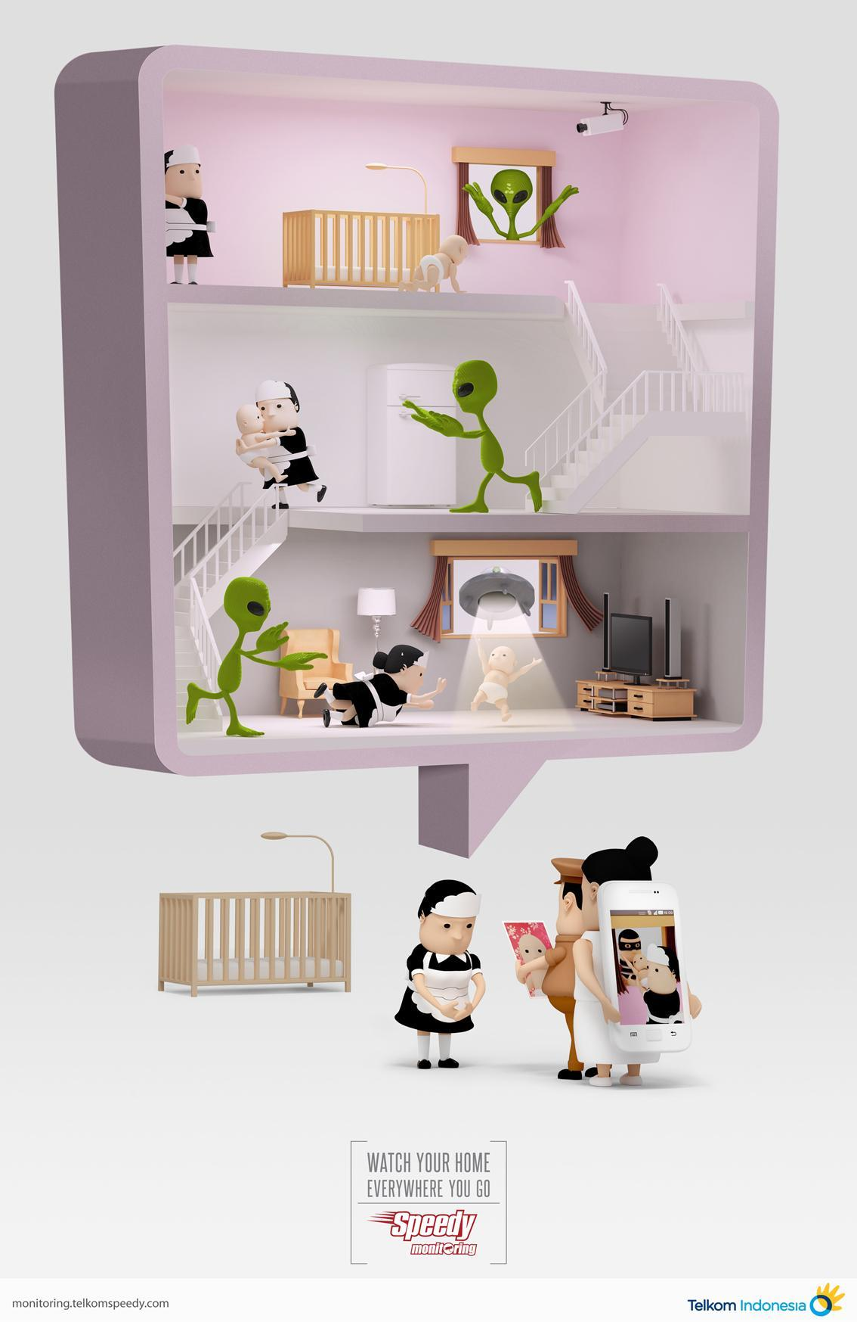

Text 2
When Franklin D. Roosevelt took the stage and delivered his first inaugural address, he beheld legions of frightened Americans. The year was 1933. A quarter of the nation was unemployed. As he bellowed those now-famous words—the only thing we have to fear is fear itself—Roosevelt couldn’t have fathomed the face of his country a mere 75 years later. For there’s no doubt that “nameless, unreasoning, unjustified terror which paralyzes needed efforts to convert retreat into advance” seizes the citizenry more tightly today than ever before.
The dangers of modern life have a stranglehold on people’s imaginations. Sociologists call the phenomenon “risk society,” describing cultures increasingly preoccupied with threats to safety, both real and perceived. Americans are fearful. Truly fearful. When they’re asked, a majority say with certainty that they know in their guts that the world is more dangerous than ever before. We lock our doors, say our prayers, and still can’t get to sleep.
In the months after 9/11, researchers now know, an understandably large number of people heeded their guts and avoided flying. Fear itself put millions of additional people in cars. Flying, however, is vastly safer than driving, and in that one year, traffic fatalities on U.S. roads spiked. An additional 1,595 people lost their lives. At the end of the year, air travel numbers returned to normal, and traffic fatalities resumed their disconcerting but regular rates.
These sorts of miscalculations happen every day: When our guts tell us not to let children play outside unsupervised, the sedentary lifestyle that inevitably results exposes kids to a host of health problems far more dangerous than the slim probability of abduction.
Marketers, politicians, and entertainers grasp with precision how brains misfire, and they apply this knowledge to great gain. Fearmongering has worked wonders for everyone from real estate agents hawking gated communities to advocacy groups attempting to recruit members.
“In 1993 there were only a few dozen antibacterial consumer products,” Mother Jones magazine reported in December. “Today, there are more than 9,000, with 2,753 new ones introduced in 2007.” Never mind that the U.S. Food and Drug Administration concluded four years ago that antibacterial soap is no better at preventing infection than regular suds: Sales of antibacterial chemicals are projected to reach $930 million in 2009. If you aren’t afraid of germs, you haven’t been watching enough TV.
Television shows seem almost single-mindedly intent on triggering our anxieties—and tend to lay the blame squarely on those fools who were not fearful enough. In a recent episode of CBS’ Criminal Minds, a pair of grief-stricken parents blubbered in front of the agents sent to recover their abducted son. The father, it seems, had argued that the 5-year-old ought to be allowed to walk to a friend’s house . . . alone. “I thought we were babying him,” he moans, as the aggrieved mother issues a stony, reproachful stare. That we can enjoy these shows as entertainment suggests the degree to which fear has become just another part of life. In the U.K., networks now broadcast public service announcements after frightening programs, providing a hotline for viewers to call if they’ve been disturbed.
The intention may be honorable, but the implication is unmistakable: What you see on TV should scare you. (And if you’re not scared, there’s probably something wrong with you.)
Adapted from “Overcoming Fear Culture and Fear Itself” by Julie Hanus (UTNE magazine, January-February, 2009)

