How the internet is changing language
By Zoe Kleinman Technology reporter, BBC News
- 16 August 2010
- From the section Technology

'To Google' has become a universally understood verb and many countries are developing their own internet slang. But is the web changing language and is everyone up to speed?
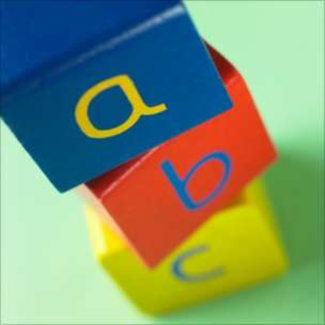
Image caption The web is a hub of neologisms

In April 2010 the informal online banter of the internet-savvy collided with the traditional and austere language of the court room.
Christopher Poole, founder of anarchic image message board 4Chan, had been called to testify during the trial of the man accused of hacking into US politician Sarah Palin's e-mail account.
During the questioning he was asked to define a catalogue of internet slang that would be familiar to many online, but which was seemingly lost on the lawyers.
At one point during the exchange, Mr Poole was asked to define "rickrolling".
"Rickroll is a meme or internet kind of trend that started on 4chan where users - it's basically a bait and switch. Users link you to a video of Rick Astley performing Never Gonna Give You Up," said Mr Poole.
"And the term "rickroll" - you said it tries to make people go to a site where they think it is going be one thing, but it is a video of Rick Astley, right?," asked the lawyer.
"Yes."
"He was some kind of singer?"

Technology and culture
This is the third of a five-part series exploring the intersection between technology and culture
Fashion buzz for stylish circuits
How pushing pixels came of age
"Yes."
"It's a joke?"
"Yes."
The internet prank was just one of several terms including "lurker", "troll" and "caps" that Mr Poole was asked to explain to a seemingly baffled court.
But that is hardly a surprise, according to David Crystal, honorary professor of linguistics at the University of Bangor, who says that new colloquialisms spread like wildfire amongst groups on the net.
"The internet is an amazing medium for languages," he told BBC News.
"Language itself changes slowly but the internet has speeded up the process of those changes so you notice them more quickly."
People using word play to form groups and impress their peers is a fairly traditional activity, he added.
"It's like any badge of ability, if you go to a local skatepark you see kids whose expertise is making a skateboard do wonderful things.
"Online you show how brilliant you are by manipulating the language of the internet."

Super slang
One example of this is evident in Ukraine, where a written variation of the national tongue has sprung up on internet blogs and message boards called "padronkavskiy zhargon" - in which words are spelled out phonetically.
It is often used to voice disapproval or anger towards another commentator, says Svitlana Pyrkalo, a producer at the BBC World Service Ukrainian Service.
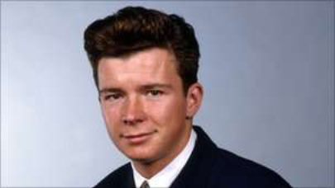
Image caption Rickrolling is the redirection of a website address to
a video of popstar Rick Astley from 1987

"Computer slang is developing pretty fast in Ukraine," she said.
The Mac and Linux communities even have their own word for people who prefer Microsoft Windows - віндузятники (vinduzyatnyky literally means "Windowers" but the "nyky" ending makes it derogatory).
"There are some original words with an unmistakably Ukrainian flavour," said Ms Pyrkalo.
The dreaded force-quit process of pressing 'Control, Alt, Delete' is known as Дуля (dulya).
"A dulya is an old-fashioned Ukrainian gesture using two fingers and a thumb - something similar to giving a finger in Anglo-Saxon cultures," she said.
"And you need three fingers to press the buttons. So it's like telling somebody (a computer in this case) to get lost."

Word play
For English speakers there are cult websites devoted to cult dialects - "LOLcat" - a phonetic and deliberately grammatically incorrect caption that accompanies a picture of a cat, and "Leetspeak" in which some letters are replaced by numbers which stem from programming code.
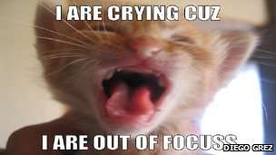
Image caption LOLcats have become a 21st Century internet phenomenon

"There are about a dozen of these games cooked up by a crowd of geeks who, like anybody, play language games," said Professor Crystal.
"They are all clever little developments used by a very small number of people - thousands rather than millions. They are fashionable at the moment but will they be around in 50 years' time? I would be very surprised."
For him, the efforts of those fluent in online tongues is admirable.
"They might not be reading Shakespeare and Dickens but they are reading and cooking up these amazing little games - and showing that they are very creative. I'm quite impressed with these movements."

Txt spk
One language change that has definitely been overhyped is so-called text speak, a mixture of often vowel-free abbreviations and acronyms, says Prof Crystal.
"People say that text messaging is a new language and that people are filling texts with abbreviations - but when you actually analyse it you find they're not," he said.
In fact only 10% of the words in an average text are not written in full, he added.
Wireless in the 1950s meant a radio. It's very rare to talk about a radio now as a wireless, unless you're of a particular generation or trying to be ironic
Fiona McPherson, Senior editor, Oxford English Dictionary
They may be in the minority but acronyms seem to anger as many people as they delight.
Stephen Fry once blasted the acronym CCTV (closed circuit television) for being "such a bland, clumsy, rythmically null and phonically forgettable word, if you can call it a word".
But his inelegant group of letters is one of many acronyms to earn a place in the Oxford English Dictionary (OED).
The secret of their success is their longevity.
"We need evidence that people are using a word over a period of time," said Fiona McPherson, senior editor in the new words group at the OED.
She says the group looks for evidence that a word has been in use for at least five years before it can earn its place in the dictionary.
Such evidence comes in the form of correspondence from the public and trawling through dated material to find out when a term first started appearing.
Hence TMI (Too Much Information) and WTF (you may wish to look that one up for yourself) are in, while OMG (Oh My God) has yet to be included in the quarterly dictionary updates.
"Some people get quite exercised and say, 'do these things belong in our language?'," said Ms McPherson.
"But maybe this has always happened. TTFN [ta ta for now] is from the ITMA (It's That Man Again) radio series in the 1940s."

Word thief
There is no doubt that technology has had a "significant impact" on language in the last 10 years, says Ms McPherson.
Some entirely new words like the verb 'to google', or look something up on a search engine, and the noun 'app', used to describe programmes for smartphones (not yet in the OED), have either been recently invented or come into popular use.

Image caption Website internetslang.com lists 5,090 English language acronyms in use.
But the hijacking of existing words and phrases is more common.
Ms McPherson points out that the phrase "social networking" debuted in the OED in 1973. Its definition - "the use or establishment of social networks or connections" - has only comparatively recently been linked to internet-based activities.
"These are words that have arisen out of the phenomenon rather than being technology words themselves," she added.
"Wireless in the 1950s meant a radio. It's very rare to talk about a radio now as a wireless, unless you're of a particular generation or trying to be ironic. The word has taken on a whole new significance."
For Prof Crystal it is still too early to fully evaluate the impact of technology on language.
"The whole phenomenon is very recent - the entire technology we're talking about is only 20 years old as far as the popular mind is concerned."
Sometimes the worst thing that can happen to a word is that it becomes too mainstream, he argues.
"Remember a few years ago, West Indians started talking about 'bling'. Then the white middle classes started talking about it and they stopped using it.
"That's typical of slang - it happens with internet slang as well."

