LANGUAGE AND CAMPAIGNS

Mental Disorders are not Adjectives
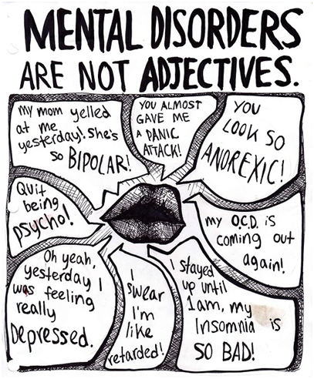
The ad above is extremely relevant to a campaign that targets mental health stigma. It spoke to me because of how relevant mental health stigma is in this day and age. Many people casually, without realizing it, use mental illnesses in their daily conversation, and they may even use those illnesses as insults. This stigma ​greatly affects those who may suffer from mental illnesses, and it shows no compassion or understanding for those in a difficult and perhaps confusing situation.
This issue has sparked numerous campaigns calling for the end of ​mental illness stigma. One of those campaigns is called Time to Change, and it is England's largest program that challenges mental health stigma and discrimination.
My questions are as follow:
1. Do you think this campaign is successful? Why or why not?​
2. How does the language used in the ad above capture your attention and add momentum to the campaign?

CVV Emotional Support Hotline
​​​This poster campaign, run by CVV took suicide notes and rearranged the words to make them mean the opposite. The tagline is: "Inside every suicide is someone who wants to live."
Attached​ are the 3 photos of real, arranged suicide notes.
*DOWN BELOW
I chose this campaign because it targets the issue of depression, something very prominent in today's society. It shows that ​we can always find light in the darkness, with the right help.
Questions:
1. Do you think that this campaign would be successful? Why or why not?
2. Do you think this campaign will encourage youth with suicidal thoughts to step up and get help? What will motivate them into doing so?
3. ​Which persuasive technique was employed most effectively in the poster? Explain your thinking.

