Written Task 1
The written task 1 can be tricky. With so much freedom, there can be many pitfalls. The requirements ask you to imitate a writing style or construct a specific type of text. Here are some of the common pitfalls that students often fall into, followed by three tips on how to avoid them.

The common pitfalls
- The written task is not an essay writing assignment. Unfortunately, many 'opinion columns' and 'blogs' end up sounding like essays.
- The context of the text is not clear. If you write an opinion column, ask yourself how it is characteristic of an opinion column from a specific newspaper or magazine. Who does it target?
- The content of the task has nothing to do with course content. For example, a brochure warning against the health dangers of bulimia does not reflect course work that explored the role of advertising in shaping young women's sense of beauty.

The right ingredients
Although there is no one guaranteed recipe for a successful written task 1, you can avoid these 'pitfalls' by including all of the following ingredients:
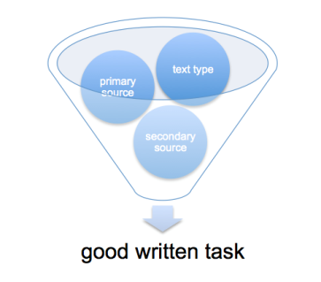
- Text type - If you write a speech, your speech should look and sound like a speech. If you write a letter to the editor, it should look and sound like a letter to the editor. In other words, each type of text has its own set of stylistic and structural conventions. Ask yourself what characteristics define the type of text you plan to write.
- Primary source - Your written task should be rooted in a primary source. If you are writing about a literary work for Part 3 or 4, the poem, novel or play is the primary source. Your task should reflect your understanding of it. For the non-literary parts of the syllabus, be sure you comment on a primary text. If you looked at the representation of women in advertising, comment on an actual ad. If you looked at a political campaign, focus on one ad, website or poster.
- Secondary source - Since the written task is not an essay, you are not asked to give your personal opinion on a subject matter or literary text. Instead, you are expected to be knowledgeable on the subject matter or the literary text. Even the best opinion columns inform readers to a great extent. You want to prove to the examiner that you have understood the course work and you have done your homework! This can also be achieved through the rationale, where applicable terms and concepts can be explained. Find secondary sources that comment on the texts you have worked on. For example, if you read an article about John Fowles and existentialism, this may inspire you to write a missing chapter to his novel, The Collector. If you explored women in advertising, you will want to find some statistics or articles on the effects of these ads on women.

