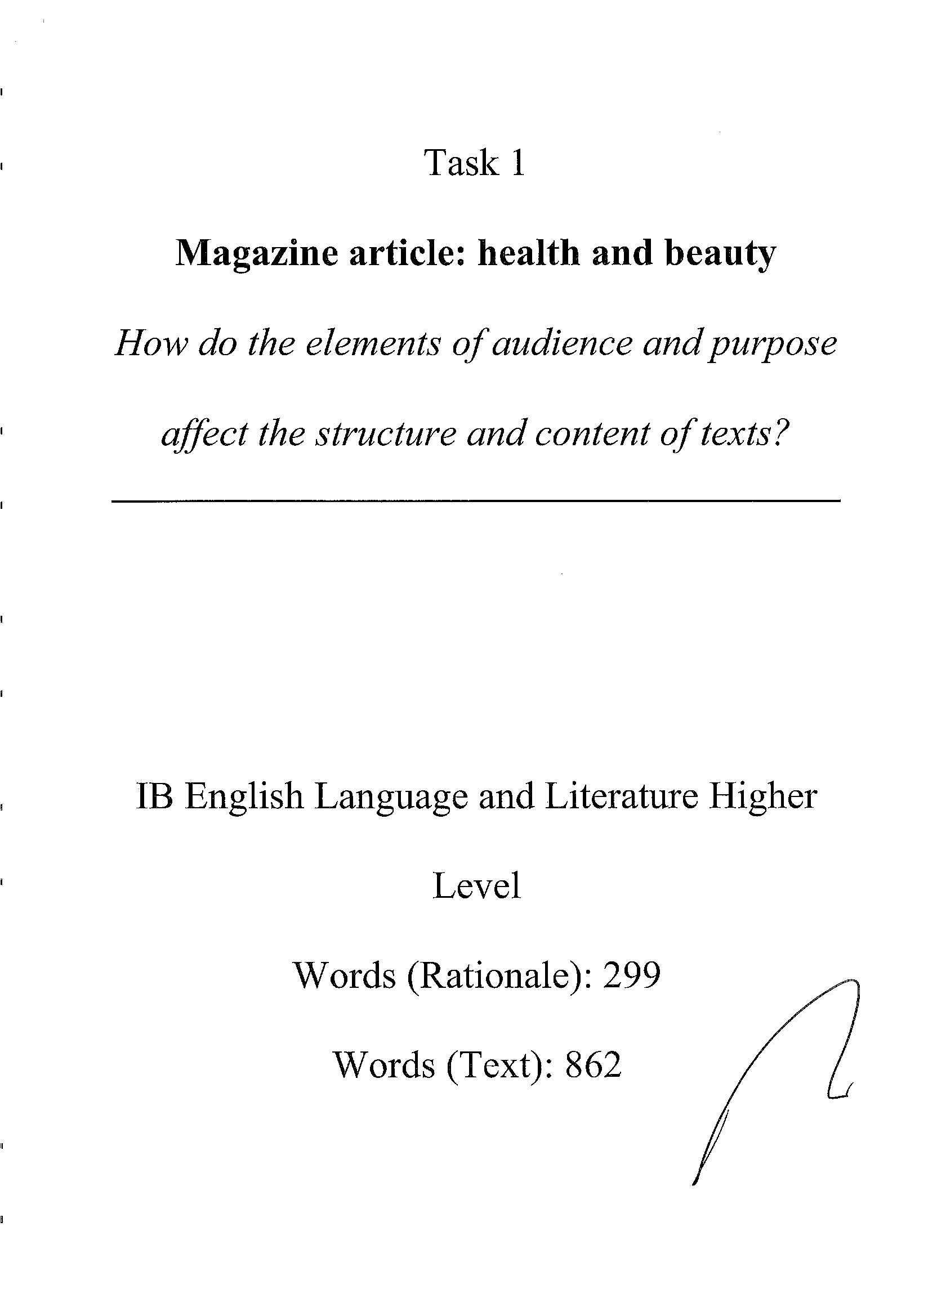
DP languages teacher support material
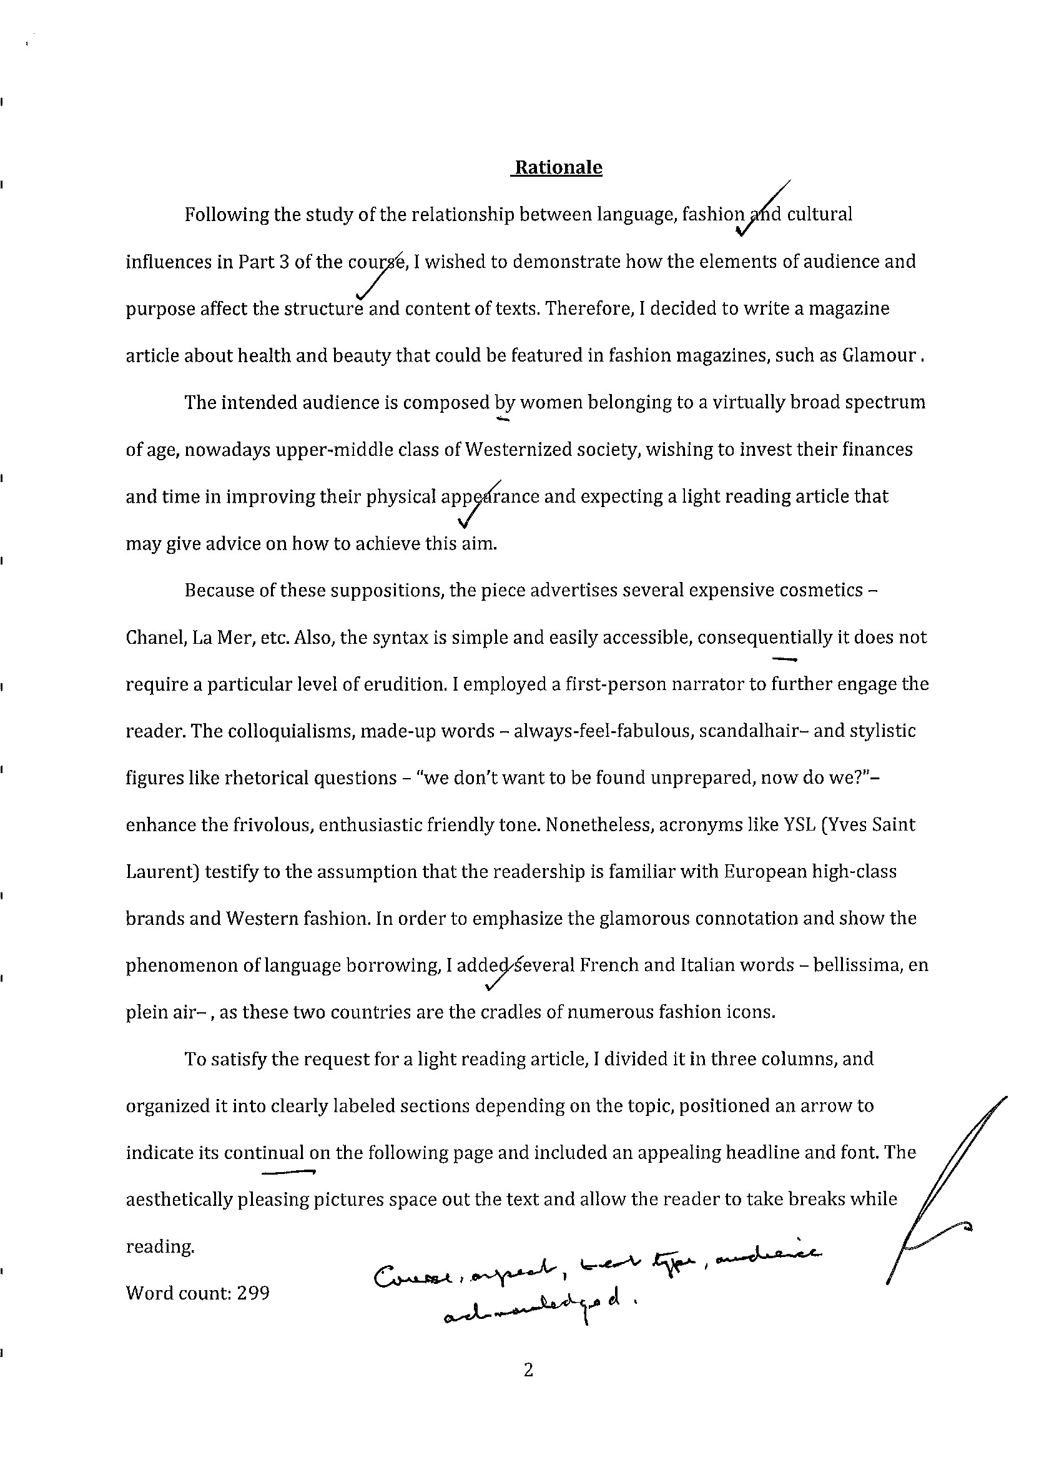
DP languages teacher support material
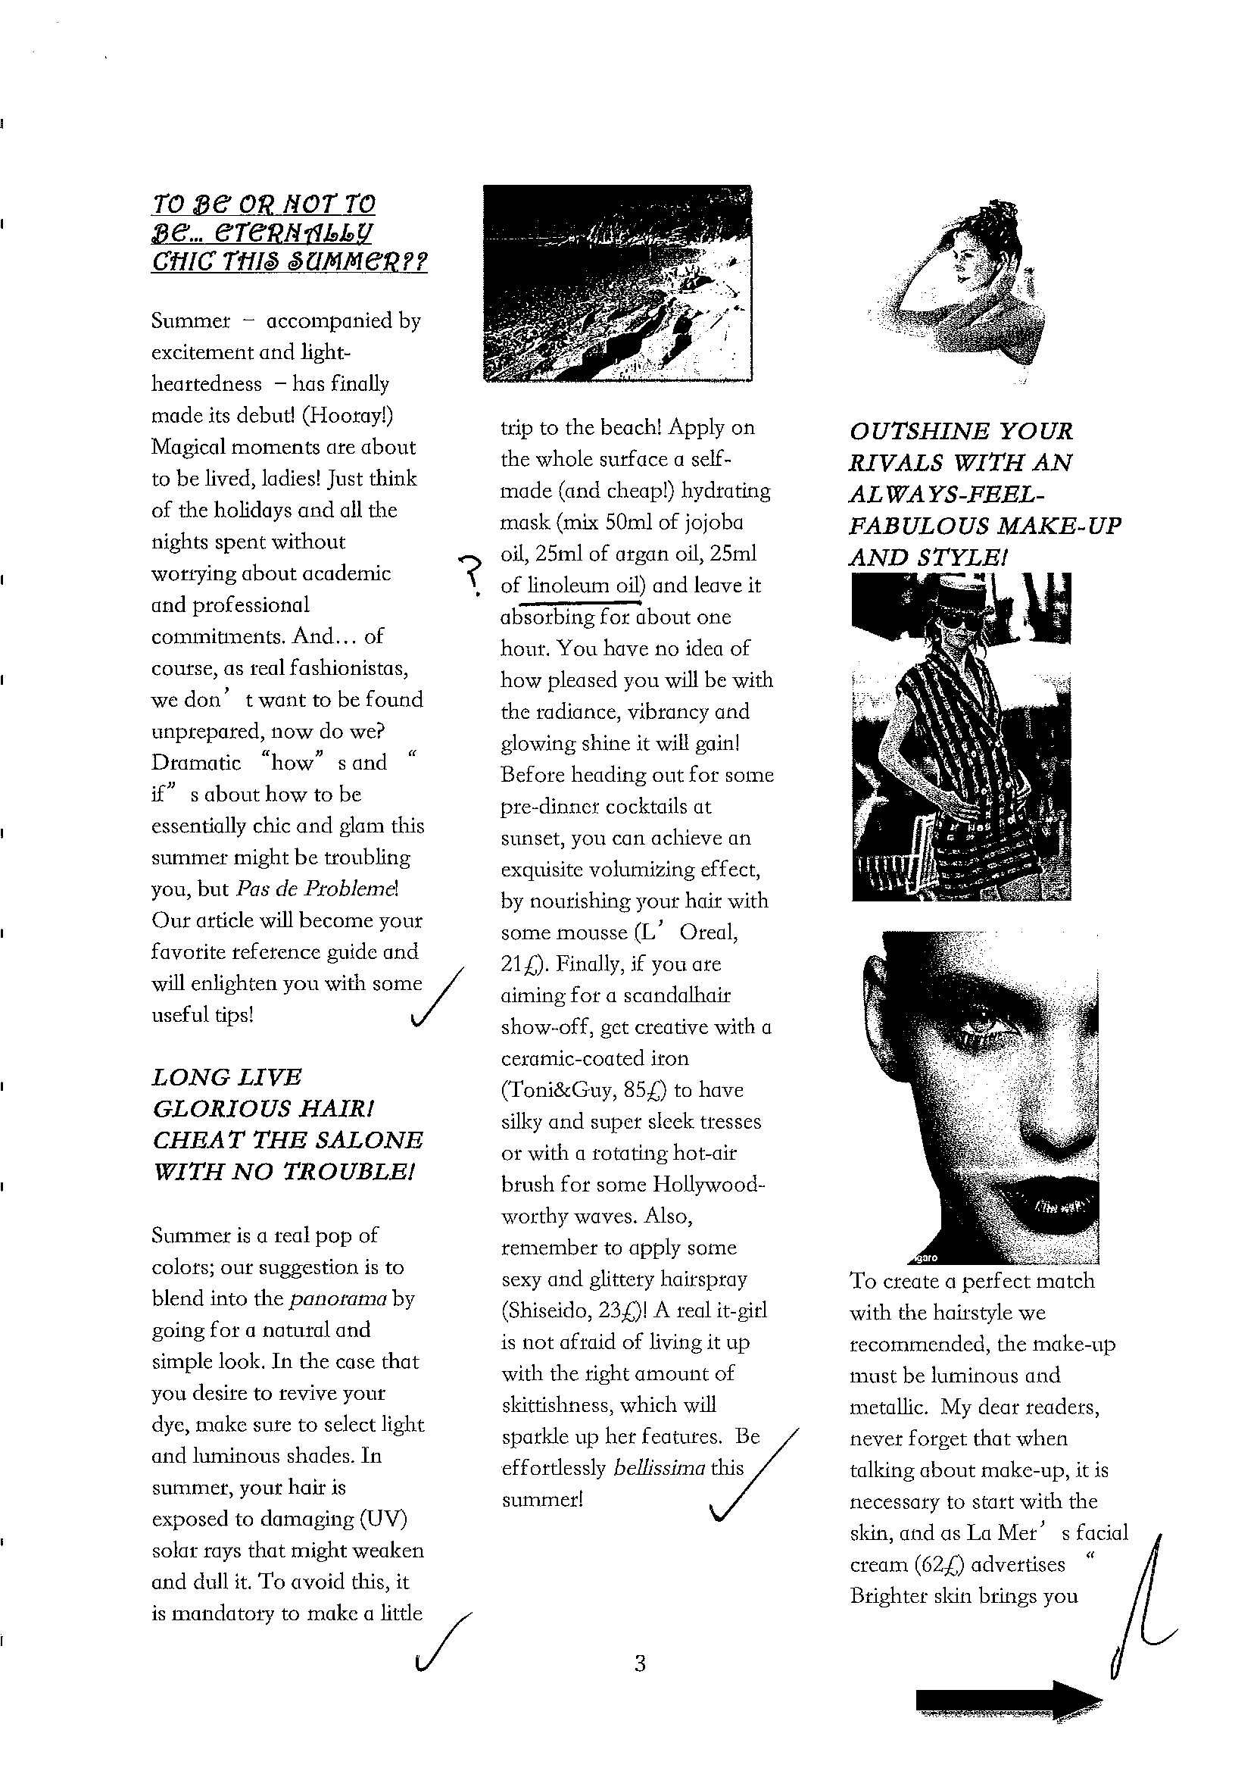
DP languages teacher support material
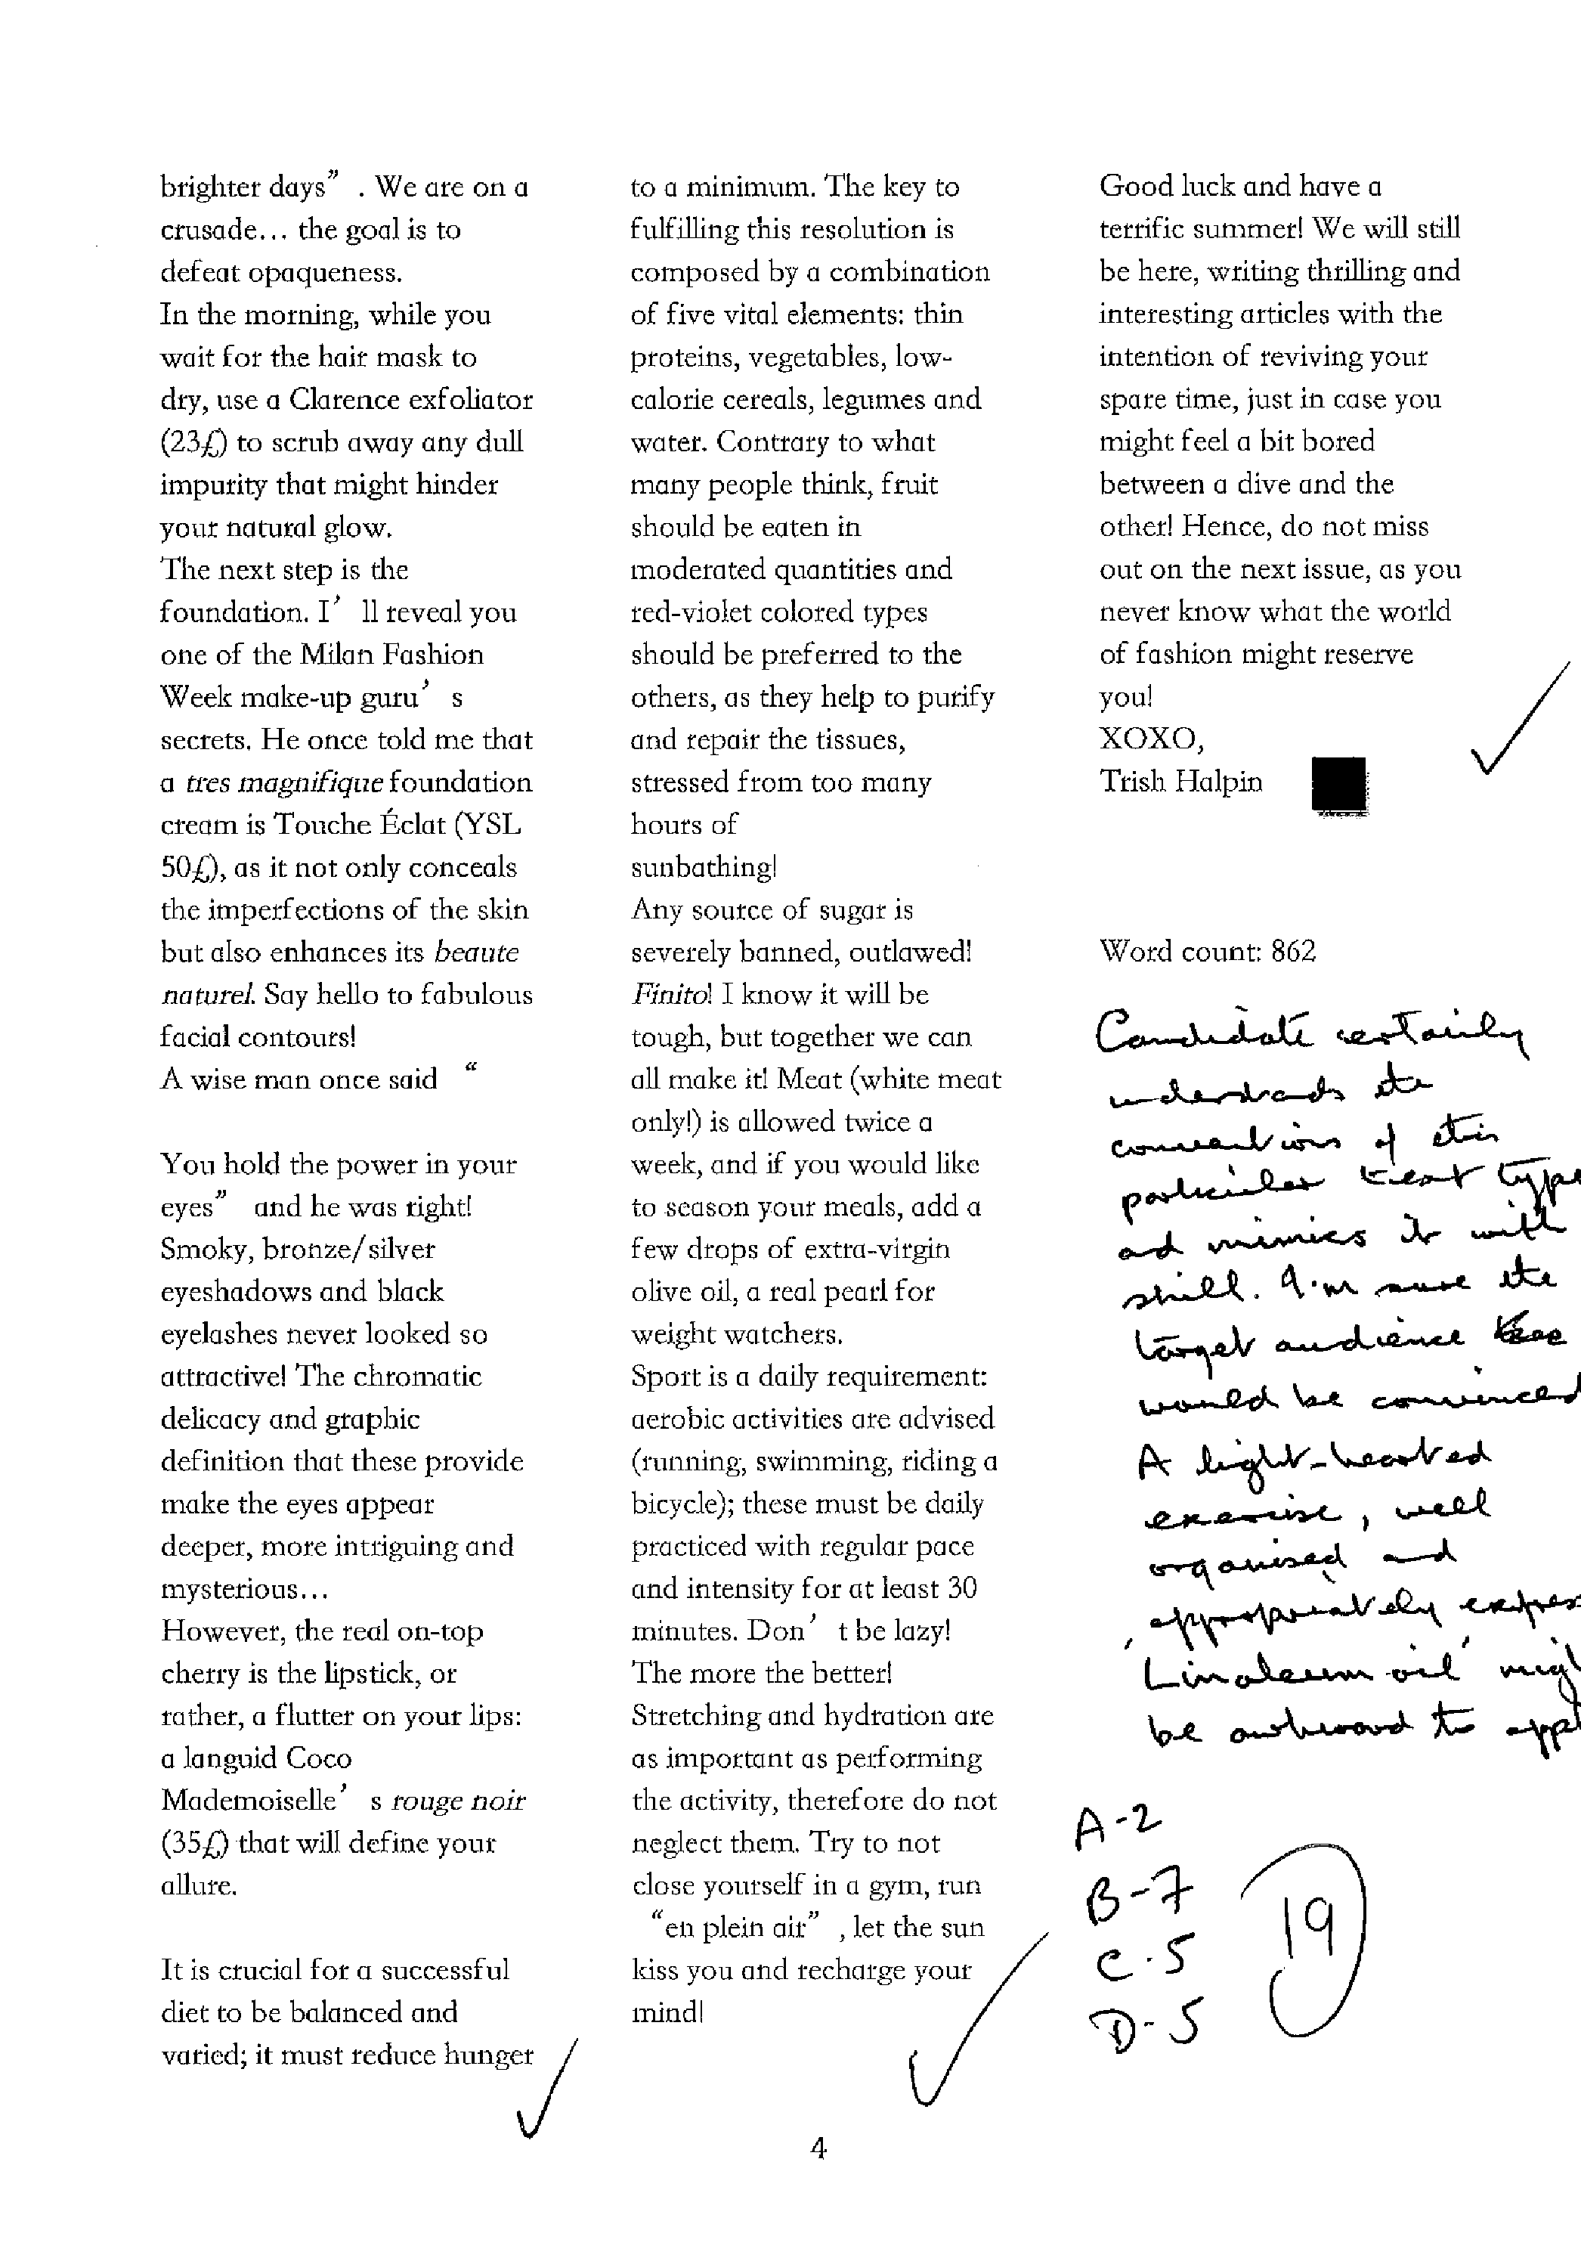
DP languages teacher supp

Criterion | A | B | C | D | Total
Marks available | 2 | 8 | 5 | 5 | 20
Marks awarded | 2 | 7 | 5 | 5 | 19

Criterion A
The rationale addresses the link to the programme, the aspect, text type and its conventions (including layout) as well as audience. Picture sources, however, have not been acknowledged.
Criterion B
This lighthearted piece of journalism, possibly a parody (although this is not stated as an objective in the rationale), nevertheless shows excellent understanding of the language aspect of the topic and of the conventions of the text type chosen. The content is consistently appropriate.
Criterion C
The task is effectively organized and coherent.
Criterion D
There are a few typographical issues and minor errors; however, the language is confident in style and register.
ort material

