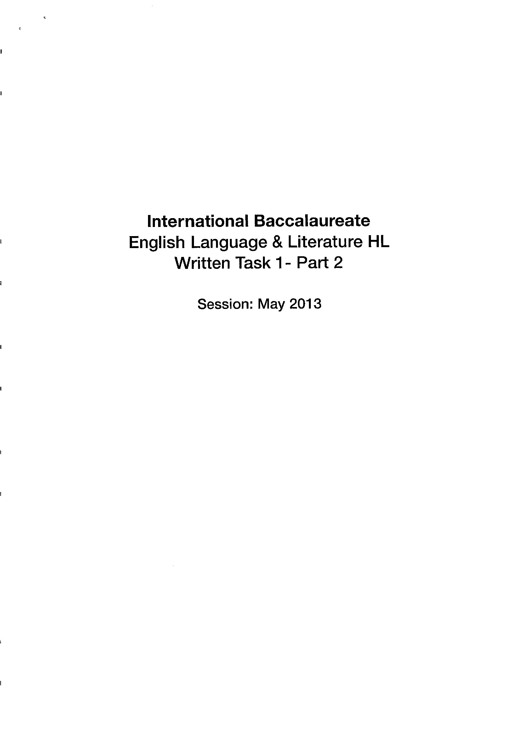
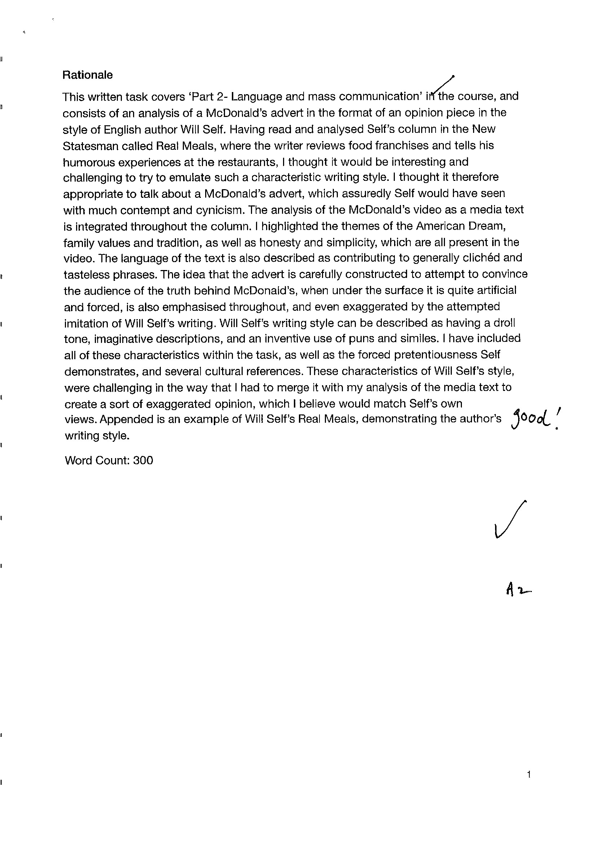
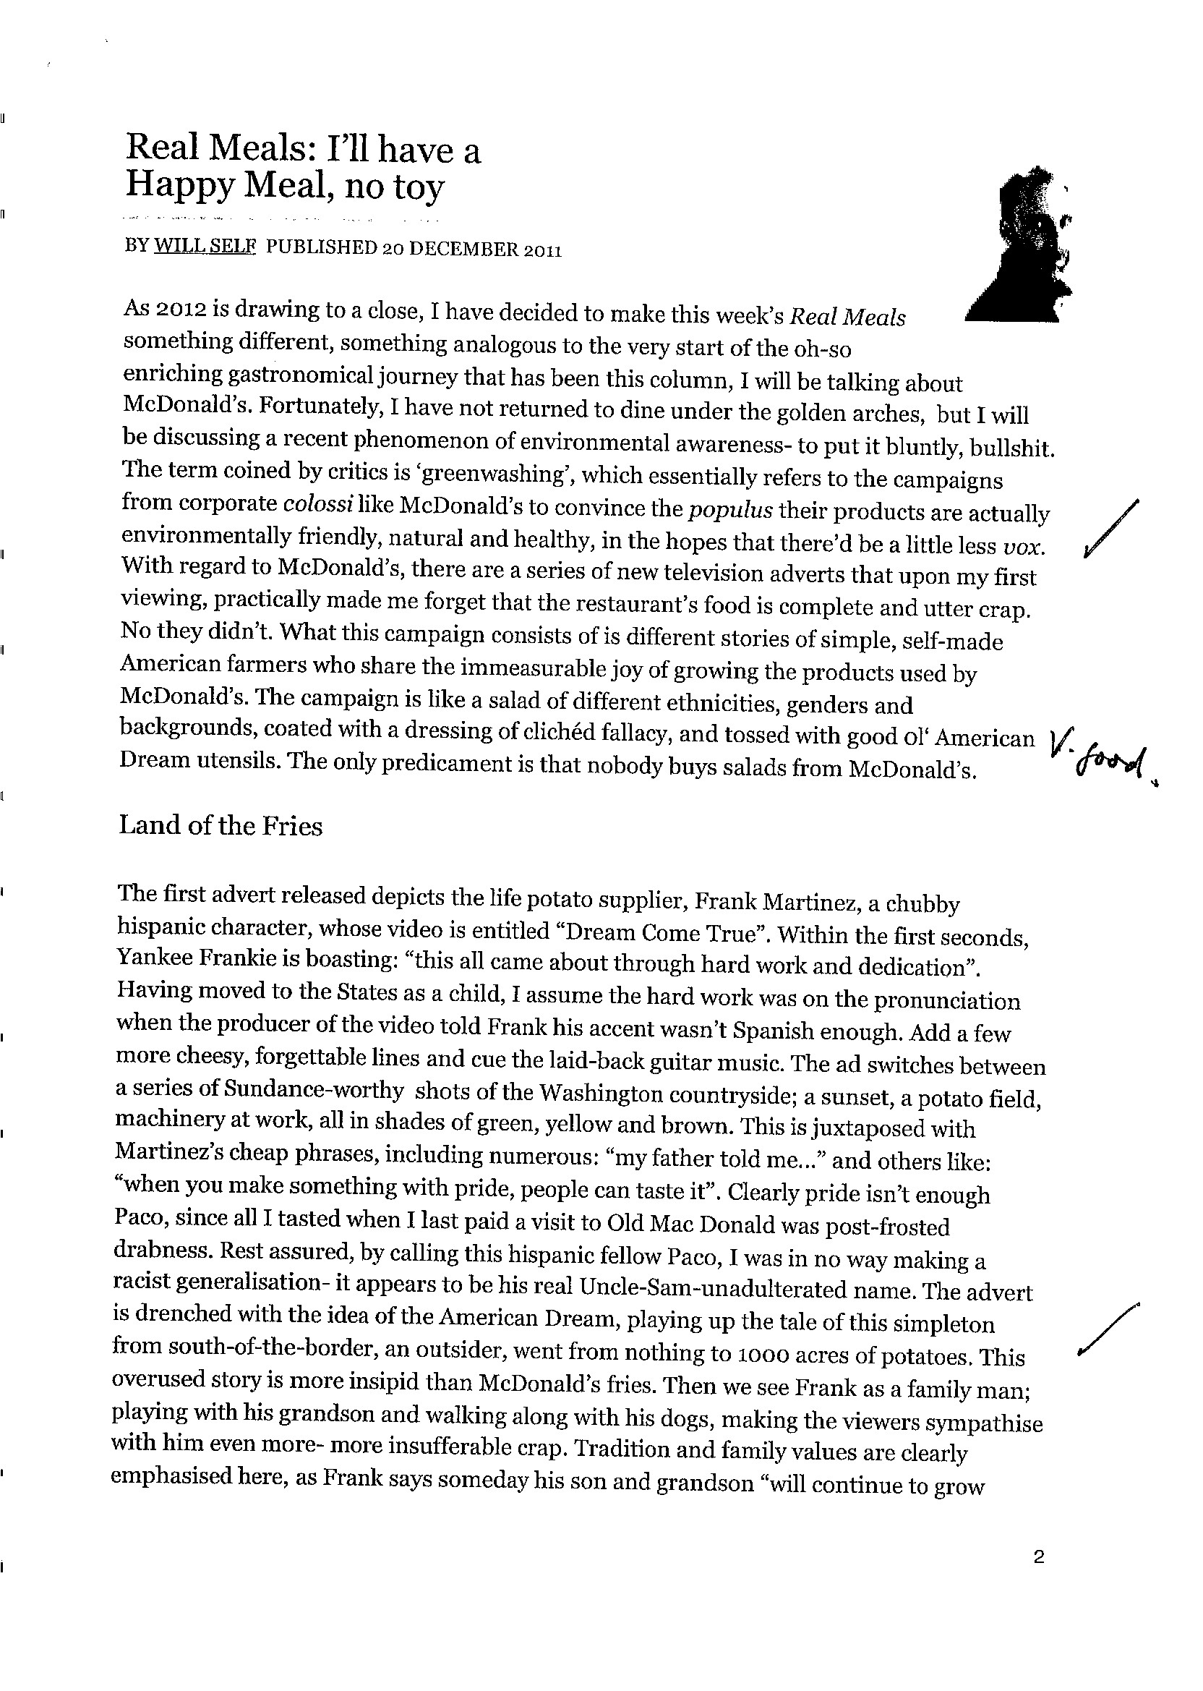
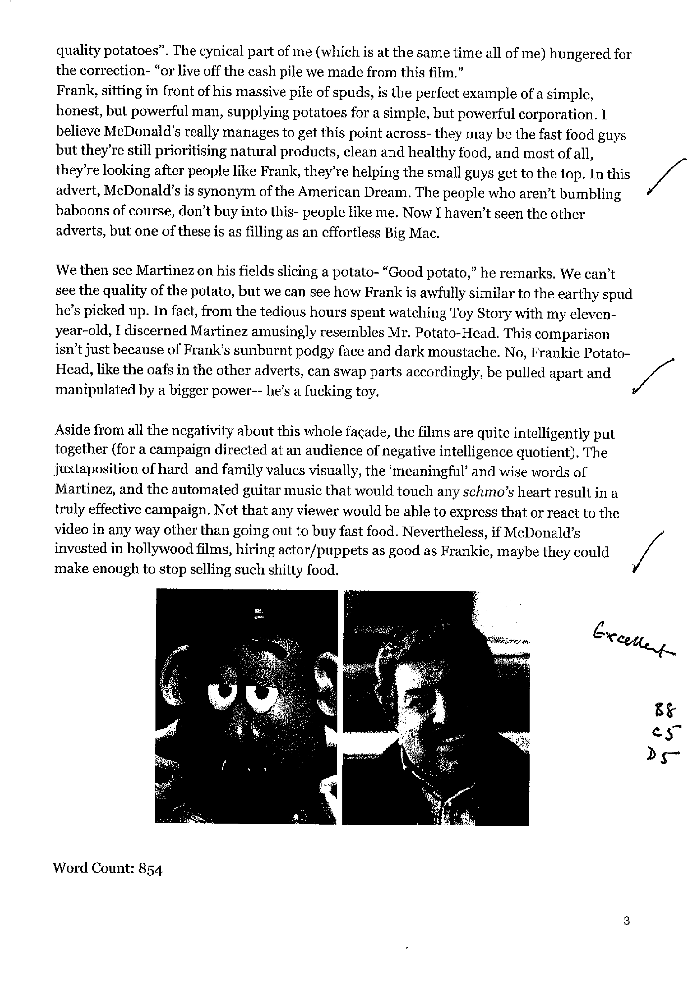
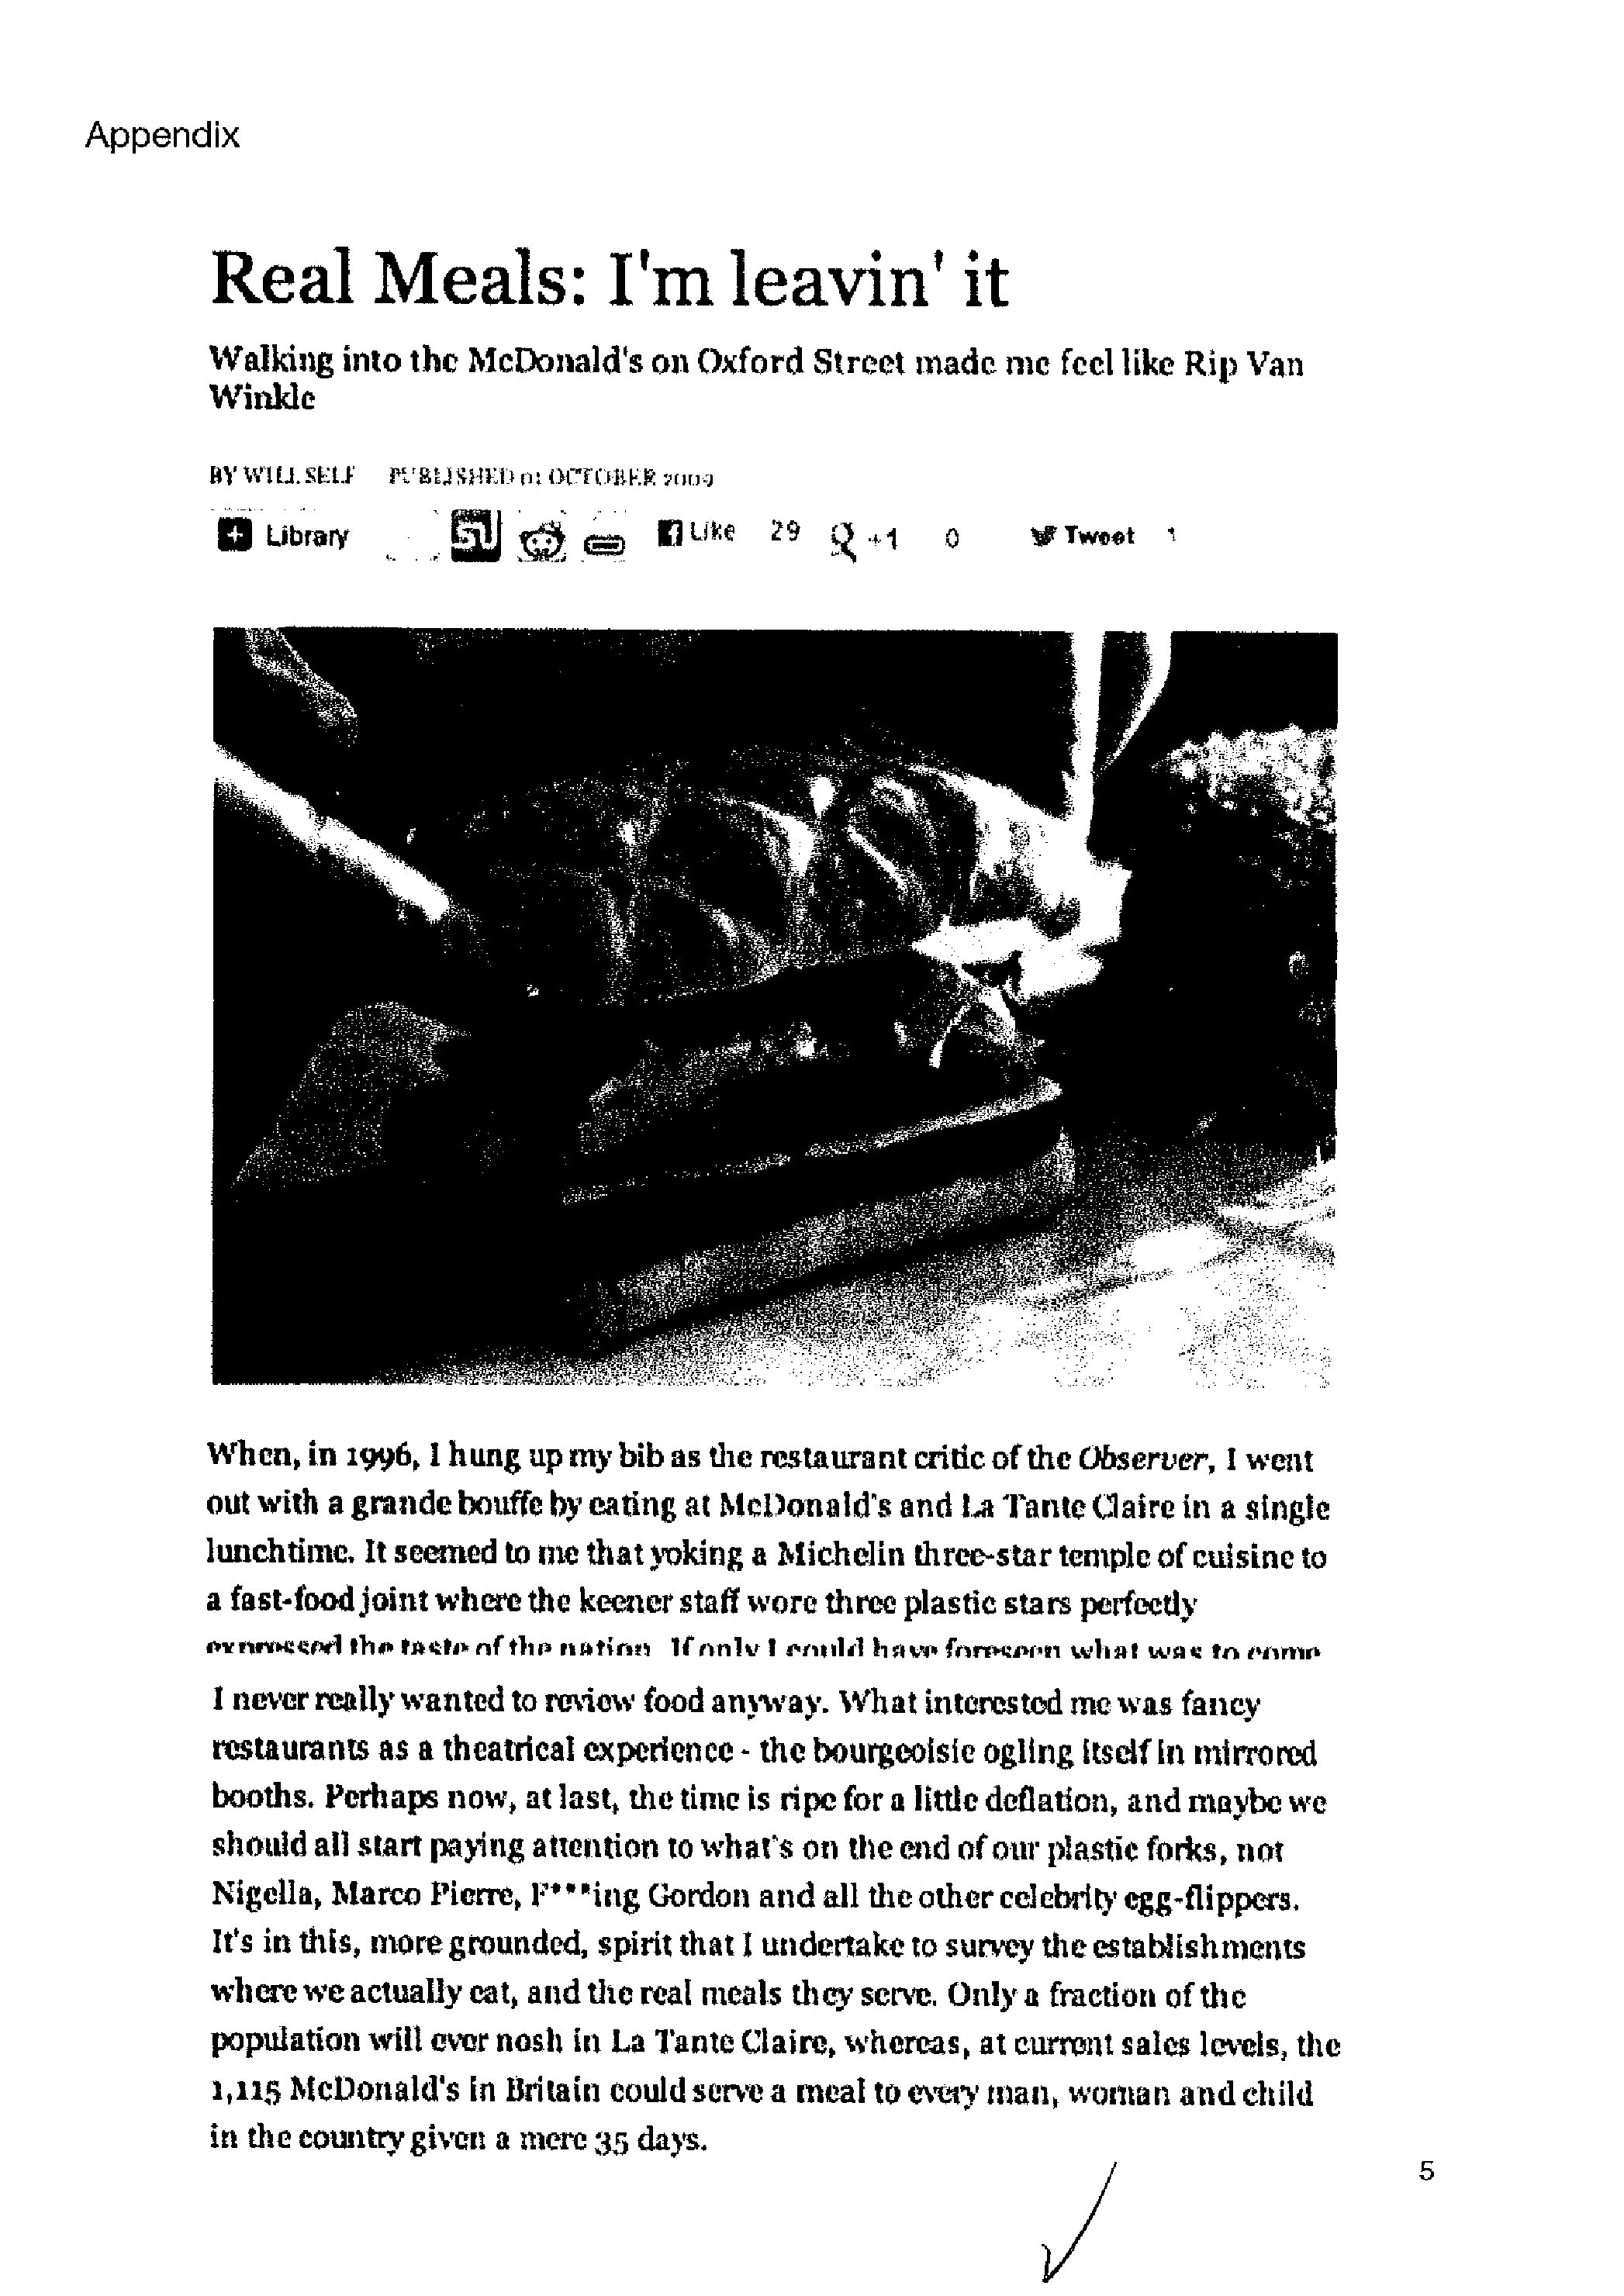
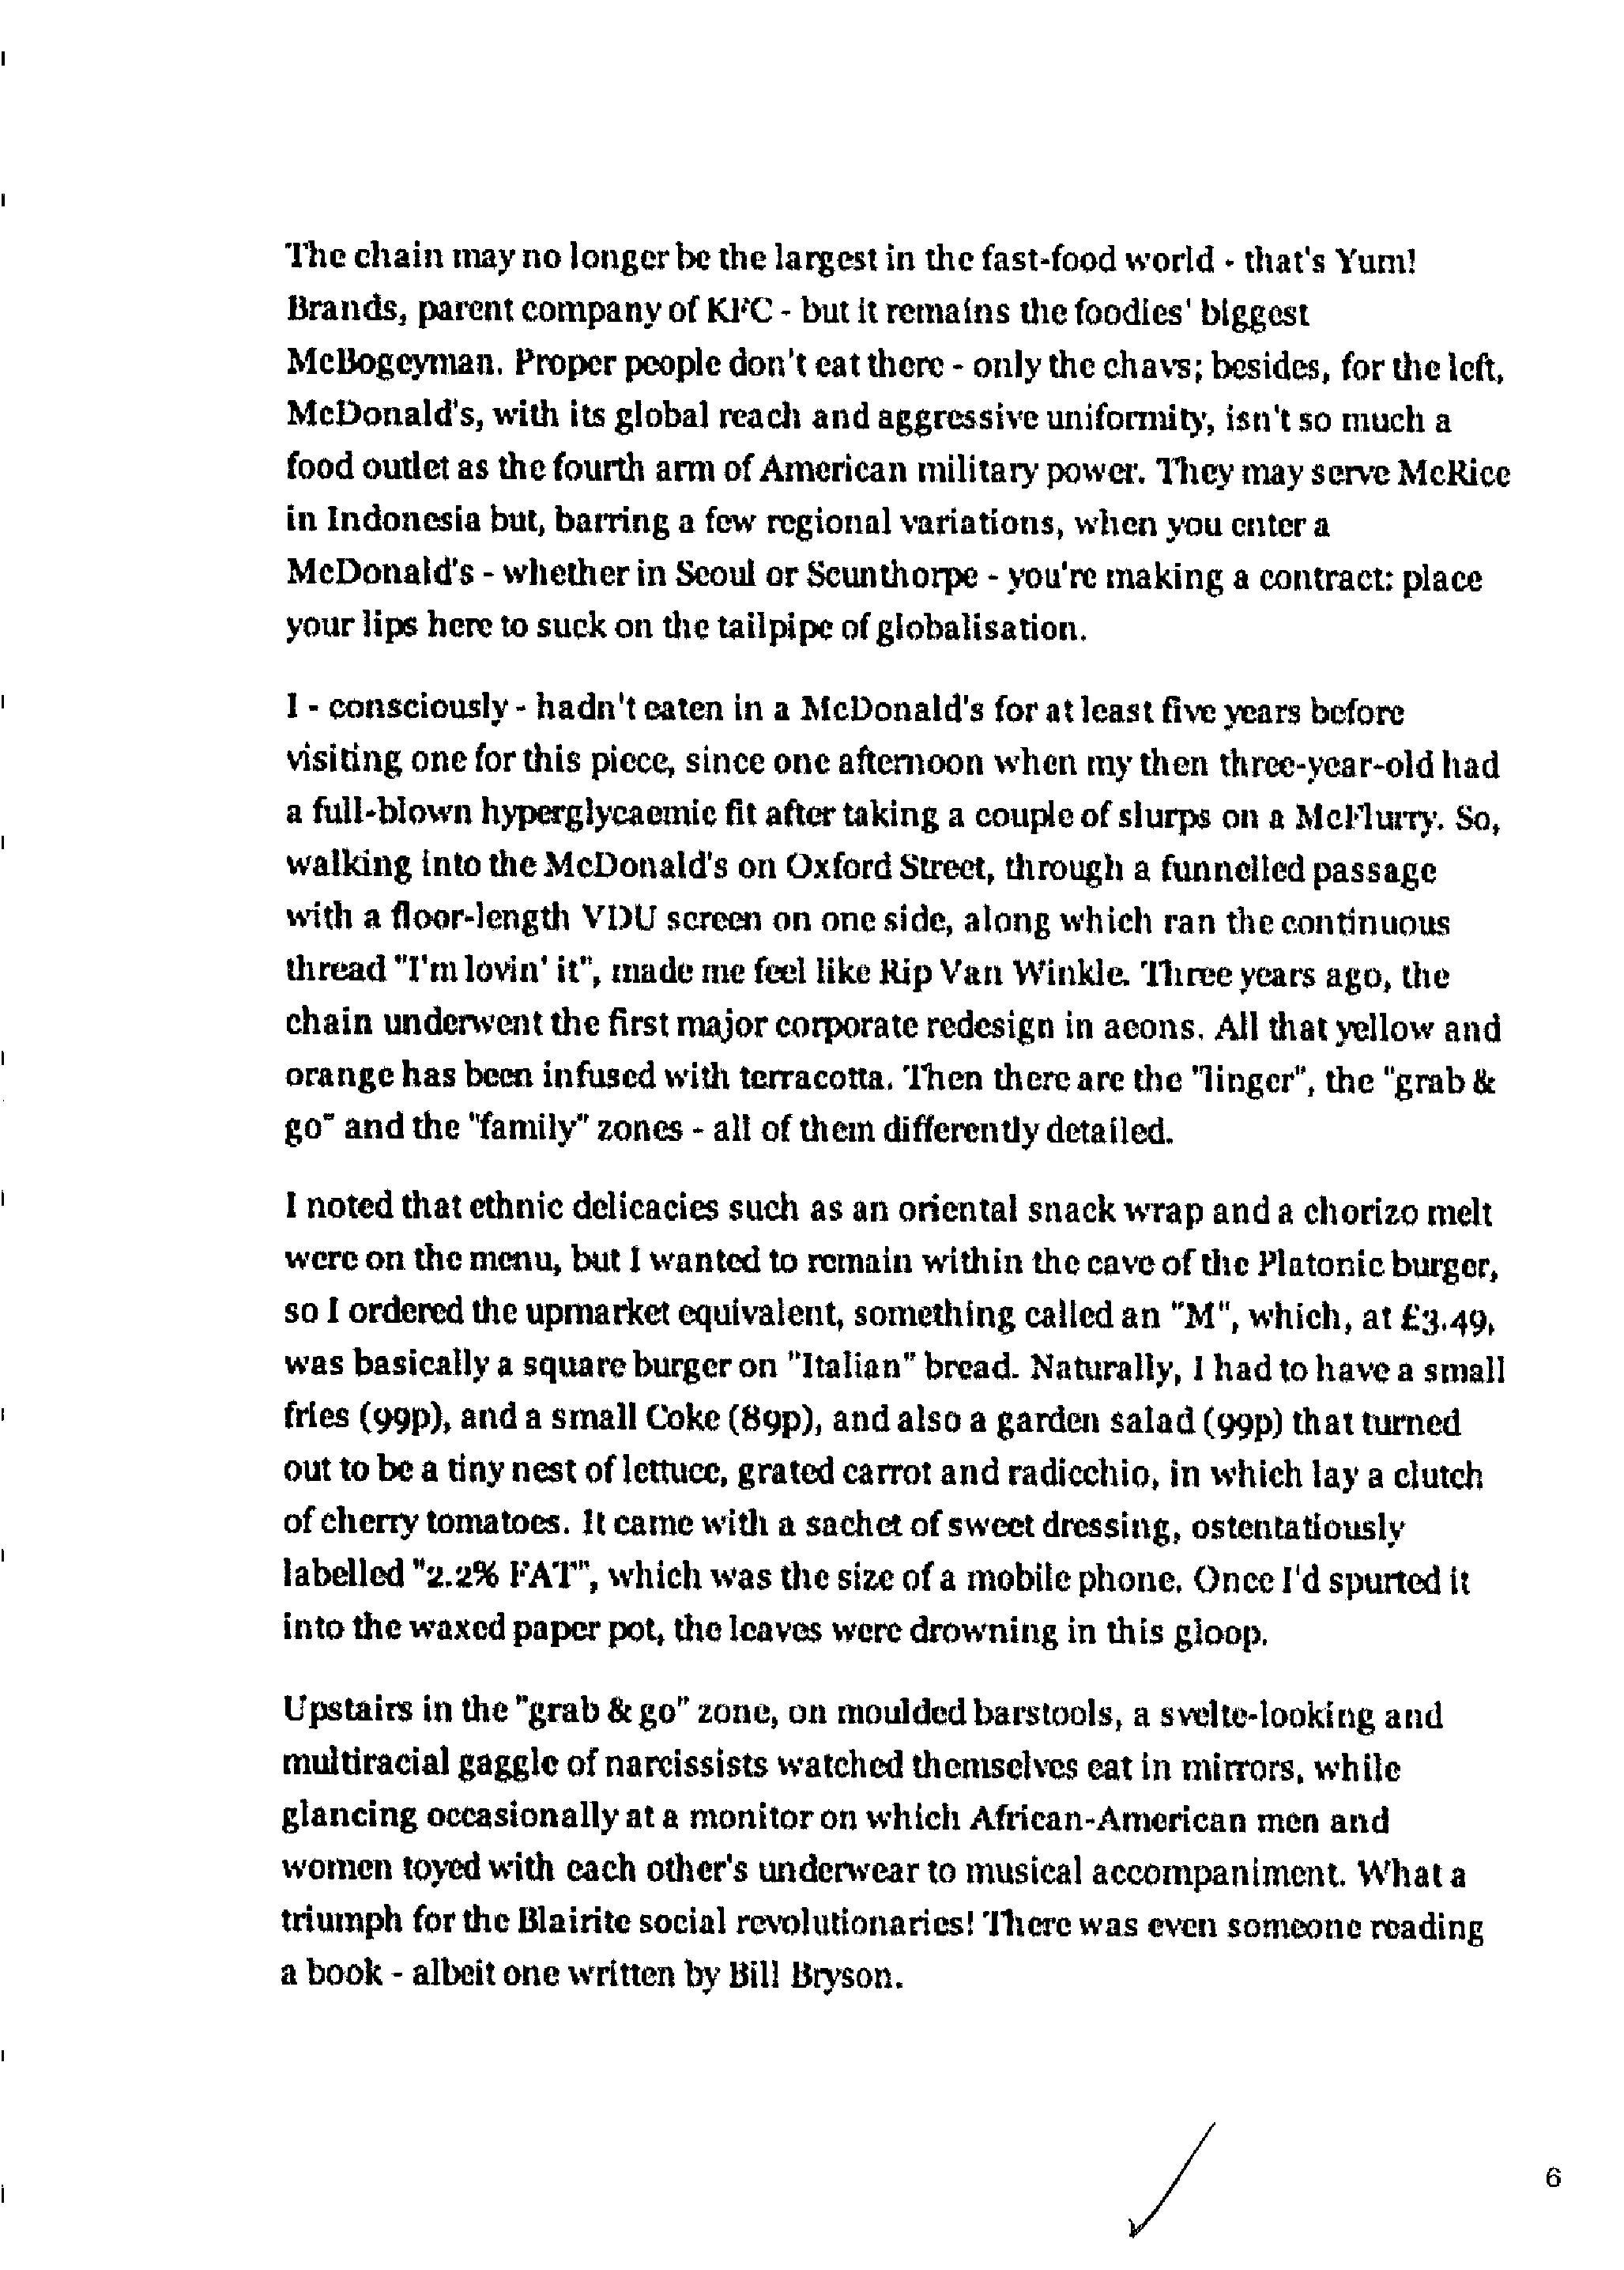

Example 12—English A: language and literature HL written task 1

Assessment
Criterion | A | B | C | D | Total
Marks available | 2 | 8 | 5 | 5 | 20
Marks awarded | 2 | 8 | 5 | 5 | 20

Criterion A
The rationale clearly explains the link to the course, the aspects to be explored and the nature of the task. It also identifies the audience, purpose and context. Stimulus material is provided.

Criterion B
The task shows an excellent understanding of the topic and the content is consistently appropriate. It not only shows an excellent understanding of the conventions of the text type, but is also a very effective pastiche of Will Self’s style.

Criterion C
The task is coherent and very effectively organized.

Criterion D
Language is very clear and effective, confident in style and effective in register.

